**Industrial Training Report**

**On**

**WEB APPLICATION USING ASP.NET (C#) AND SQL SERVER**

**at**

**IT DIVISION, DG: AIR**

**(PRASAR BHARTI)**



**For the partial fulfillment of the requirements for the award of the degree of**

**Bachelor of Engineering (Computer Science Engineering)**

**Submitted to:**

**IT Division, P&D Unit, Akashwani Bhawan, New Delhi**

**Submitted by:**

**Sarthak Jain (Maharaja Agrasen Institute of Technology, New Delhi)**

**Under the guidance of :**

**Mr. Priyank Saxena (Engineering Assistant)**

**Mr. Sandeep Srivastava (Deputy Director, IT)**

**Candidate’s Declaration**

I hereby declare that the work, which is being presented in this report, entitled “**RWA Complaint Management System** ” in partial fulfillment for the award of Degree of “Bachelor of Technology” in Department of **Computer Science Engineering** of “**Maharaja Agrasen Institute of Technology**” affiliated to “**Guru Gobind Singh Indraprastha University**” is a record of my own investigations carried under the Guidance of **Mr. Sandeep Srivastava (Deputy Director, IT)**, **Mr.** **Priyank Saxena (Engineering Assistant)** of **IT DIVISION, Directorate General: All India Radio, Prasar Bharati**.

I have not submitted the matter presented in this report anywhere for the award of any other Degree.

**Name: SARTHAK JAIN**

**Roll no.: 09214802716**

**Priyank Saxena T.P Singh Sandeep Srivastava  
 (E.A., IT) (A.D., IT) (D.D., IT)**

**Acknowledgement**

The ability to help and patience to exercise diligence and provide support is a quality Admonished by very few. Any job in this world, however trivial or tough cannot be accomplished without the assistance of the others. It is my pleasure to be indebted to various People who directly or indirectly contributed in the development of this report and who influenced my thinking, behavior and acts during the period of training.

First and foremost I would like to thanks Mr. Pradeep Mehra (Director, IT), Mr. Sandeep Srivastava (Deputy Director, IT) and Mr. T.P Singh (Assistant Director, IT) for providing unwavering support and opportunity to work in this organization.

I wish to express my deep sense of gratitude and appreciation to Mr. Priyank Saxena (Engineering Assistant) who explained me everything about the training process at the company and made me familiar with the company staff. During the entire duration of project he instilled enthusiasm, appreciation for fine details and a keen sense of observation in us. He has been a guiding source of light and always been an anchor in times when we would meet with regular setbacks in our project. Sir, brought optimism and always had belief in us at every step of the way something we will cherish forever.

I am also grateful to other IT staff that has been a constant source of inspiration, knowledge and motivation.Finally, yet importantly, I would like to express my heartfelt thanks to my beloved parents and teachers for their blessings, help and wishes for the successful completion of this report.

**Table of Contents**

**Abstract**

**List of Figures**

**Chapter 1 Field & Technology**

* 1. Introduction
     1. Features of ASP.NET
     2. Architecture
     3. .NET Libraries

**Chapter 2 ASP .NET Application Development**

**Chapter 3 Project**

3.1 Introduction to **RWA Complaint Management System**

3.2 Screenshots

**Chapter 4 System Analysis**

4.1 Introduction

4.2 Data Flow Diagram

4.3 Entity Relationship Diagram

4.4 Use Case Diagram

**Chapter 5 Feasibility Study**

5.1 Project Testing

**Chapter 6: Future Scope**

**Conclusion**

**References**

**ABSTRACT**

*RWA Complaint Management System in a Radio Colony is a project that evolved from an idea to help the resident. The residents of Radio Colony, Kingsway Camp can a make an online complaint through our website. Here, the complaint are classified as Civil and Electrical . These different categories of complaint deals by two separate hierarchy of officers viz JE(E), AE(E),etc for electrical complaints and same for civil.*

*The residents can even see the status of their complaint which incorporates a transparency and time efficiency in a system. With the help of this website you can see which authority is dealing with your complaint and the file flow with remarks given by respective officers*

*RWA Complaint Management System in layman terms is a website created using Microsoft Visual Studio and SQL Server, consisting of multiple web pages that can be accessed and allows the user to connect to other residents of their colony*

*RWA Complaint Management System is a continuously evolving project. For this reason, we realize the need of having a strongly secured database, a website immune to any unethical cyber-attacks.*

**COMPANY PROFILE**

**IT DIVISION, Directorate General: All India Radio**

**(Prasar Bharati)**



All India Radio (AIR), officially known since 1956 as Akashvani (literally, "Voice from the Sky"), is the national public radio broadcaster of India and a division of Prasar Bharati. Established in 1930, it is the sister service of Prasar Bharati's Doordarshan, the national public television broadcaster. AIR has covered more than 99% of the Indian Population as per the latest information given by Minister of Information and Broadcast. All India Radio is one of the largest radio networks in the world. Its headquarters is at the Akashvani Bhawan in New Delhi. Akashvani Bhawan houses the Drama Section, the FM Section and the National Service. Doordarshan Kendra (Delhi) offices are also located on the sixth floor at Akashvani Bhawan.

**Chapter 1**

**Field and Technology**

**1.1 Introduction to the technology used:**

**ASP.NET:-**

ASP.NET is an open-source server-side Web application framework designed for Web development to produce dynamic web pages. It was developed by Microsoft to allow programmers to build dynamic web sites, web application and web services.

It was first released in January 2002 with version 1.0 of the .NET framework, and is the successor to Microsoft’s Active Server Pages (ASP) technology. ASP.NET is built on the Common Language Runtime (CLR), allowing programmers to write ASP.NET code using any supported .NET language. The ASP.NET SOAP extension framework allows ASP.NET components to process SOAP messages.

ASP.NET consists of .NET framework on which code is written. Recently ASP.NET MVC is going on which is a web application framework developed by Microsoft, which implements the Model-View-Controller (MVC) pattern. It is open-source software, apart from the ASP.NET Web forms component which is proprietary

**1.1.1Features of ASP.NET:**

**Microsoft ASP.NET contains many extended features. Few of them are listed below:**

**Code Behind Model:** Microsoft recommends dealing with dynamic program code by using the code-behind model, which places this code in a separate file or in a specially designated script tag.

**User Controls:** User controls are encapsulations of sections of pages which are registered and used as controls in ASP.NET, org.etc.

**Rendering Techniques:** It uses “visited composites” rendering technique. During compilation, the template (.aspx) file is compiled into initialization code which builds a control free representing the original template. That code is combined with user-written code & results in a class specific for the page.

**State Management:** .NET applications are hosted by web server and are accessed using the stateless HTTP protocol. It consists of Application, Session state, SQL server mode, State Server Mode. Application state is held by a collection of shared user-defined variables. Sever side Session State is held by a collection of user-defined session variables that are persistent during a user session.

**Others Files:** These includes asax, ascx, aspx, browser, config, vbhtml etc. These files extensions associated with different versions of ASP.NET.

**1.1.2. Architecture:**

ASP.NET has extended into multiple code frameworks including Web Forms, MVC, Web pages, Web API and Signal. Now we can develop our websites using Web forms, MVC, or Web pages or service provided by Web API or Signal



**Fig: 1.1 Architecture of ASP.NET**

**1.1.3. ASP.NET Class Libraries:**

Windows SDK class library includes a subset of namespaces that allow us to create ASP.NET Websites, components & controls. Below section describe key namespaces for ASP.NET development.

**System. Web:**

Contains classes & interfaces that enable browser/server communication. This namespace provides classes for managing HTTP output to the client.

**System. Web. UI:**

Contains classes for creating web form pages, including the Page class & other standard classes used to create web User Interfaces.

**System. Web. UI. Html Controls:**

Contains classes for HTML specific controls that can be added to web forms to create Web user interfaces.

**System. Web. UI. Web Controls. Web Parts**:

Contains an integrated set of classes & interfaces for creating Web pages whose appearance & behavior can be modified by end users.

**System. Configuration:**

Provides classes & interfaces that allow to programmatically access.

**System. Web. Configuration**:

Contain classes used to setup ASP.NET Configuration.

**Chapter 2:**

**PROJECT (COMPLAINT MANAGEMENT)**

These days when everyone is engaged at work, there is no time to sit and relax and know more about the surrounding they are living in. People usually miss the activities happening around them in their society. So, to get an update of what happened all day, they can simply visit the RWA COMPLAINT MANAGEMENT SYSTEM website of their colony.

The resident can browse through the gallery and see new events coming up in the colony so he/she could schedule their days accordingly. RWA COMPLAINT MANAGEMENT SYSTEM is a basic website project, created in Microsoft Visual Studio 2013 with the help of ASP.NET (platform) and C# (language). RWA COMPLAINT MANAGEMENT SYSTEM is a fully independent website capable of hosting multiple web pages that provides member registration functionality, login functionality and many others.

There are multiple scripting languages in which web pages can be created. We worked on ASP.NET since ASP.NET is a basic implementation of the .NET Framework over variety of Internet services and the websites and they run on the same server. Majority of existing companies continue to use ASP.NET as it gives an individual greater independence and control over a variety of elements that make web pages. What made ASP.NET ideal for RWA COMPLAINT MANAGEMENT SYSTEM is the fact that ASP.NET is economical, provides higher scalability options and has provisions for inbuilt security features such as authorization and authentication along with a plethora of others.

RWA COMPLAINT MANAGEMENT SYSTEM is also aimed to be extremely user-friendly. The user interface has been designed to allow users to navigate swiftly, efficiently and easily from one page to another. To keep it clutter free, we have mentioned only the relevant details that concern the user. Currently the language of the user interface in which RWA COMPLAINT MANAGEMENT SYSTEM is made public will be in English. However we intend to provide RWA COMPLAINT MANAGEMENT SYSTEM in other languages so that colonies in every part of India wish to have a website representing their own RWA COMPLAINT MANAGEMENT SYSTEM.

Along with web page designing we focused on creation database design that comes in to the picture when a large number of activities and events will happen in the colony, which needs to be updated to the site. Database design is something that comes fundamentally in to the picture when dealing with big data-dealing with large information updates, retrieval, modification and deletion. Hence RWA COMPLAINT MANAGEMENT SYSTEM incorporates best of both the worlds- webpage design along with database design to handle variety of constraints and demands.

**1.1 Purpose**

RWA COMPLAINT MANAGEMENT SYSTEM website is made to connect all the residents of the colony as one big family, these days when everyone is engaged at work, there is no time to sit and relax and know more about the surrounding they are living in. People usually miss the activities happening around them in their society. So, to get an update of what happened all day, they can simply visit the RWA COMPLAINT MANAGEMENT SYSTEM website of their colony.

The resident can browse through the gallery and see new events coming up in the colony so he/she could schedule their days accordingly. People can relive the moments by checking the gallery and can announce their big or small events on the website and invite others.

**1.2 Scope**

RWA COMPLAINT MANAGEMENT SYSTEM has been developed to provide the people involved with it to know about the day-to-day activities in their society. RWA COMPLAINT MANAGEMENT SYSTEM website has the following features:

1. RWA COMPLAINT MANAGEMENT SYSTEM provides the facility to add members to the group anytime.

2. RWA COMPLAINT MANAGEMENT SYSTEM provides admin with the option to check the designation of any member and change it if needed

3. RWA COMPLAINT MANAGEMENT SYSTEM allows members to upload relevant details of any event coming up.

4. In COMPLAINT MANAGEMENT, we also have a database that contains all the information of registered members like their name, address, designation, age, username and password for the account created. events and functions happening at colony.

5. We also have another database designed that stores the information about the

**1.3 Definitions, Acronyms and Abbreviations**

1. ASP-Active Server Pages:

Microsoft's Server side script engine for creating dynamic web page. These are frequently created and used in Microsoft Visual Studio.

2. ASPX- Active Server Page extended

.ASPX is the file extension for an ASP NET active server page. It's a web technology used on Microsoft servers running Internet Information Services and ASP NET. ASPX documents have code in them with regard to styling and other functionalities that you would like to see on your webpage.

3. .NET-Network Enabled Technologies

4. MSVS-Microsoft Visual Studio

5. SQL-Structured Query Language

a language for management of data in a relational structure,

6. CSS-Cascading Style Sheets

is a computer language that is used to write formatting instructions (rules). These rules tell a web browser how webpage content should look in terms of: layout. position, alignment, width, height, etc.

7. AJAX-Asynchronous Javascript and XML

is a client-side script that communicates to and from a server/database without the need for a post back or a complete page refresh. The best definition I've read for Ajax is "the method of exchanging data with a server, and updating parts of web page without reloading the entire page

8. HTTP-Hyper Text Transfer Protocol

is an application protocol for distributed, collaborative, hypermedia information systems. HTTP is the foundation of data communication for the World Wide Web. Hypertext is structured text that uses logical links (hyperlinks) between nodes containing text.

9. IDE-Integrated Development Environment

is a software application that provides comprehensive facilities to computer programmers for software development. An IDE normally consists of a source code editor, build automation tools and a debugger.

10. IIS-Internet Information Service

is a group of Internet servers (including a Web or Hypertext Transfer Protocol server and a File Transfer Protocol server) with additional capabilities for Microsoft's Windows NT and Windows 2000 Server operating systems.

11. MVC-Model View Controller

is an architectural patter that separates an application into three main logical components: the model, the view, and the controller.

12. SDK-Software Development Kit

13. TCP-Transmission Control Protocol

is a core protocol of the Internet protocol suite. It originated in the initial network implementation in which it complemented the Internet Protocol (IP). Therefore, the entire suite is commonly referred to as TCP/IP.

14. WAP-Wireless Access Protocol

protocol that enables access to the intemet from mobile phones and PDAs.

15. XML-Extended Mark-up Language

is a markup language that defines a set of rules for encoding documents in format that is both human-readable and machine-readable.

**2.1 Perspective on RWA COMPLAINT MANAGEMENT SYSTEM**

RWA COMPLAINT MANAGEMENT SYSTEM has been created to connect the people and their activities so that everyone in the society shares a bond and are there for each other in times of need as a family.

**2.2 RWA COMPLAINT MANAGEMENT SYSTEM FUNCTIONS**

RWA COMPLAINT MANAGEMENT SYSTEM provides online real time information about the activities of the COMPLAINT MANAGEMENT. Depending on whether you want to avail or contribute to RWA COMPLAINT MANAGEMENT SYSTEM the work is done. The WebPages that have been involved in the construction of RWA COMPLAINT MANAGEMENT SYSTEM and various functionalities it provides at every stage to the user are:

All of the pages share some common attributes which will be discussed as follows. All of these pages were created in Microsoft Visual Studio 2017; each page has its two parts one page corresponds to the .aspx code and another to the .cs code.

The aspx file contains all the code relevant to designing of the webpage that is including tables, images, labels, textboxes and other dynamic functionalities. This page is perhaps a crucial element and one that requires a lot of hard work, diligence to work, maintain and keep updating.

.cs file contains code with respect to more sensitive functionalities-like when you click the submit button on the register page for submitting your entered information where will it redirect to? Many questions parallel to this are answered using this page. Any unnecessary changes here can hurt the file and the entire project.

**Chapter 3:**

**Source Code of RWA COMPLAINT MANAGEMENT SYSTEM**

**Web Config**

<?xml version="1.0"?>

<configuration>

<system.web>

<compilation debug="true" targetFramework="4.5" />

<httpRuntime targetFramework="4.5" />

</system.web>

<appSettings>

<add key="ValidationSettings:UnobtrusiveValidationMode" value="None" />

</appSettings>

<connectionStrings>

<add name="con" connectionString="Data Source=RIPCODE;Initial Catalog=rwa;Integrated Security=True" />

</connectionStrings>

</configuration>

3.1 Site Master

<%@ Master Language="C#" AutoEventWireup="true" CodeBehind="Site1.master.cs" Inherits="WebApplication2.Site1" %>

<!DOCTYPE html>

<html xmlns="http://www.w3.org/1999/xhtml">

<head runat="server">

<title></title>

<meta name="viewport" content="width=device-width, initial-scale=1" />

<style>

ul {

list-style-type: none;

margin: 0;

padding: 0;

overflow:hidden;

background-color: #333;

text-decoration:none;

position:relative;

}

li {

float: right;

}

li a {

display: block;

color: white;

text-align: center;

padding: 5px 16px;

margin-right:3vw;

text-decoration: none;

font-size:x-large;

}

li a:hover {

background-color: #111;

}

.logo

{

float:left;

display: block;

color: white;

text-align: center;

margin-left:50px;

font-size:xx-large;

text-decoration: none;

}

body{

background-repeat: no-repeat;

background-position: top;

background-size:cover;

background-image: url('images/society6.png');

width:100%;

}

</style>

<asp:ContentPlaceHolder ID="headcontent" runat="server"></asp:ContentPlaceHolder>

</head>

<body id="divbody" runat="server" >

<form id="form2" runat="server">

<ul>

<li><a class="active" href="#logout" > <asp:LinkButton ID="LinkButton1" runat="server" OnClick="LinkButton1_Click" CausesValidation="False">Log Out</asp:LinkButton></a></li>

<li class="logo" >Radio colony<sub style="font-size:large">Kingsway Camp</sub></li>

</ul>

<asp:ContentPlaceHolder ID="maincontent" runat="server"></asp:ContentPlaceHolder>

</form>

</body>

</html>

3.1 Home

<%@ Page Language="C#" AutoEventWireup="true" CodeBehind="home.aspx.cs" Inherits="WebApplication2.home" %>

<!DOCTYPE html>

<html xmlns="http://www.w3.org/1999/xhtml" lang="en">

<head runat="server">

<title>

</title>

<meta name="viewport" content="width=device-width, initial-scale=1" />

<meta charset="utf-8"/>

<!-- Latest compiled and minified CSS -->

<link rel="stylesheet" href="https://maxcdn.bootstrapcdn.com/bootstrap/3.3.7/css/bootstrap.min.css"/>

<!-- jQuery library -->

<script src="https://ajax.googleapis.com/ajax/libs/jquery/3.3.1/jquery.min.js"></script>

<!-- Latest compiled JavaScript -->

<script src="https://maxcdn.bootstrapcdn.com/bootstrap/3.3.7/js/bootstrap.min.js"></script>

<style>

ul {

list-style-type: none;

margin: 0;

padding: 0;

overflow:hidden;

background-color: #333;

text-decoration:none;

position:relative;

}

li {

float: right;

}

li a {

display: block;

color: white;

text-align: center;

padding: 5px 16px;

margin-right:3vw;

text-decoration: none;

font-size:x-large;

}

li a:hover {

background-color: #111;

}

.logo

{

float:left;

display: block;

color: white;

text-align: center;

margin-left:50px;

font-size:xx-large;

text-decoration: none;

}

#divbody {

background-repeat: no-repeat;

background-position: top;

background-size:cover;

background-image: url('images/society6.png');

width:100%;

}

#Button1

{

align-content:center;

margin-left:3vw;

border-radius:25px;

border-width:5px;

border:groove;

padding:10px;

padding-left:20px;

padding-right:20px;

}

.login

{

background-color:lightgrey ;

padding:3vw;

margin-left:70vw;

margin-right:3vw;

margin-top:5vw;

opacity:0.9;

font-size:x-large;

border-radius:20px;

min-width:250px;

}

.footer

{

margin-bottom:0;

margin-top:1vw;

text-align: center;

font-family: 'Comic Sans MS';

font-size: xx-large;

display: block;

}

.feature

{

float:left;

margin:6vw;

border-radius:20px;

padding:20px;

}

@media screen and (max-width: 500px ) {

.login {

background-color: lightgrey;

padding: 4vw;

margin-left: 0vw;

margin-right: 0vw;

margin-top: 10vw;

opacity: 0.9;

font-size: medium;

border-radius: 20px;

width:100%;

}

.logo

{

float:none;

display: block;

color: white;

text-align: center;

margin-left:0px;

font-size:larger;

text-decoration: none;

}

.size

{

font-size:large;

text-align:center;

}

ul {

list-style-type: none;

margin: 0;

padding: 0;

overflow:hidden;

background-color: #333;

text-decoration:none;

position:relative;

}

li

{

float:none;

}

li a {

display: block;

color: white;

text-align: center;

padding: 5px 16px;

margin-right:1vw;

text-decoration: none;

font-size:medium;

}

}

@media screen and (max-width:1400px ) {

.login {

background-color: lightgrey;

padding: 4vw;

margin-left: 30vw;

margin-right: 30vw;

margin-top: 10vw;

opacity: 0.9;

font-size: x-large;

border-radius: 20px;

min-width: 250px;

}

}

@media screen and (max-width:900px ) {

.login {

background-color: lightgrey;

padding: 4vw;

margin-left: 10vw;

margin-right: 26vw;

margin-top: 10vw;

opacity: 0.9;

font-size: x-large;

border-radius: 20px;

min-width: 250px;

}

li a {

display: block;

color: white;

text-align: center;

padding: 5px 10px;

margin-right: 1vw;

text-decoration: none;

font-size: large;

}

.logo

{

float:none;

display: block;

color: white;

text-align: center;

margin-left:0px;

font-size:large;

text-decoration: none;

}

}

</style>

</head>

<body id="divbody" runat="server" >

<form id="form1" runat="server">

<ul>

<li class="logo" >Radio colony<sub class="size">Kingsway Camp</sub></li>

<li><a class="active" href="#home" > <asp:LinkButton ID="LinkButton1" runat="server" OnClick="LinkButton1_Click" CausesValidation="False">Sign Up</asp:LinkButton></a></li>

<li><a href="#news"> <asp:LinkButton ID="LinkButton2" runat="server" OnClick="LinkButton2_Click" CausesValidation="False">Contact Us</asp:LinkButton></a></li>

<li><a href="#contact"> <asp:LinkButton ID="LinkButton3" runat="server" OnClick="LinkButton3_Click" CausesValidation="False">Home</asp:LinkButton></a></li>

</ul>

<div class="login ,container">

<asp:Label ID="Label1" runat="server" Text="E-mail"></asp:Label><br />

<asp:TextBox ID="txtusername" Placeholder="UserName" runat="server"></asp:TextBox>

<asp:RequiredFieldValidator ID="RequiredFieldValidator1" runat="server" ControlToValidate="txtusername" ErrorMessage="Email Reqd!!" ForeColor="Red"></asp:RequiredFieldValidator>

<br/><br />

<asp:Label ID="Label2" runat="server" Text="Password"></asp:Label><br />

<asp:TextBox ID="txtpwd" Placeholder="Password" runat="server" TextMode="Password"></asp:TextBox>

<asp:RequiredFieldValidator ID="RequiredFieldValidator2" runat="server" ControlToValidate="txtpwd" ErrorMessage="Password Reqd!!" ForeColor="Red"></asp:RequiredFieldValidator>

<br /><br />

<asp:Button ID="Button1" runat="server" Text="LOG IN" style="background-color:#8d8a8a;font-size:large" OnClick="Button1_Click"/>

</div>

<div class="footer" >

<div class="feature" style="background-color:#6bc9e6">

Complaint Registration

</div>

<div class="feature" style="background-color:#b6ff00">

24x7 connectivity

</div>

<div class="feature" style="background-color:#ead666">

Events

</div>

</div>

</form>

</body>

</html>

C# code:

using System;

using System.Collections.Generic;

using System.Linq;

using System.Web;

using System.Web.UI;

using System.Web.UI.WebControls;

using System.Web.Configuration;

using System.Configuration;

using System.Data.SqlClient;

using System.Data;

namespace WebApplication2

{

public partial class home : System.Web.UI.Page

{

protected void Page_Load(object sender, EventArgs e)

{

}

protected void Button1_Click(object sender, EventArgs e)

{

String conf = WebConfigurationManager.ConnectionStrings["con"].ConnectionString;

SqlConnection conn = new SqlConnection(conf);

conn.Open();

DataSet ds = new DataSet();

SqlCommand cmd = new SqlCommand("SP_registration", conn);

cmd.CommandType = CommandType.StoredProcedure;

cmd.Parameters.AddWithValue("@Email_ID", txtusername.Text);

cmd.Parameters.AddWithValue("@flag", 2);

SqlDataAdapter da = new SqlDataAdapter(cmd);

da.Fill(ds);

if (ds.Tables[0].Rows.Count > 0)

{

string username = ds.Tables[0].Rows[0][0].ToString();

string password = ds.Tables[0].Rows[0][1].ToString();

if (username == txtusername.Text && password == txtpwd.Text)

{

Session["validloginflag"] = 1;

Session["candidateid"] = ds.Tables[0].Rows[0][3].ToString();

if (Convert.ToInt16(ds.Tables[0].Rows[0][4]) == 1 || Convert.ToInt16(ds.Tables[0].Rows[0][4]) == 2 || Convert.ToInt16(ds.Tables[0].Rows[0][4]) == 3)

{

Session["usertype"] = ds.Tables[0].Rows[0][4].ToString();

Session["loginofficerid"] = ds.Tables[0].Rows[0][5].ToString();

Response.Redirect("CompliantStatus.aspx", true);

}

else

{

Response.Redirect("complaint.aspx", true);

}

}

else

{

ScriptManager.RegisterStartupScript(this, this.GetType(), "Script", "alert('Authentication Failed!!!!!!')", true);

}

}

else

{

ScriptManager.RegisterStartupScript(this, this.GetType(), "Script", "alert('Authentication Failed!!')", true);

}

}

protected void LinkButton1_Click(object sender, EventArgs e)

{

Response.Redirect("signup.aspx");

}

protected void LinkButton2_Click(object sender, EventArgs e)

{

Response.Redirect("contact.aspx");

}

protected void LinkButton3_Click(object sender, EventArgs e)

{

Response.Redirect("home.aspx");

}

}

}

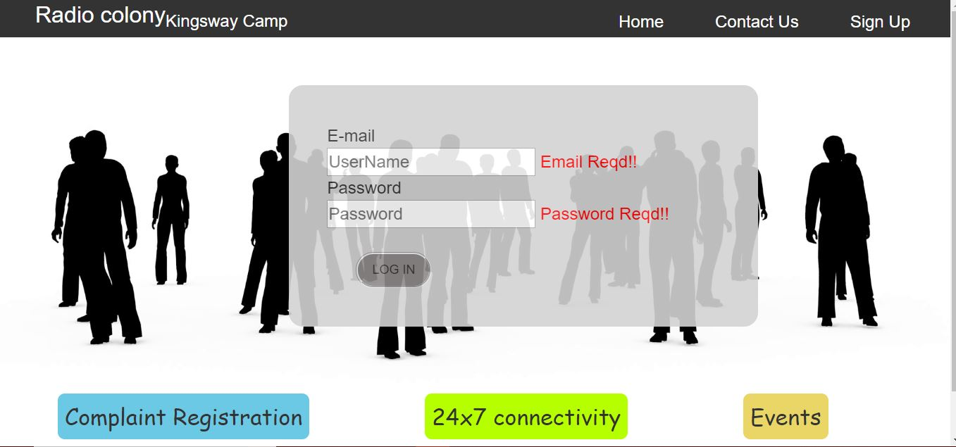

3.2 Contact

<%@ Page Language="C#" AutoEventWireup="true" CodeBehind="contact.aspx.cs" Inherits="WebApplication2.contact" %>

<!DOCTYPE html>

<html xmlns="http://www.w3.org/1999/xhtml" lang="en">

<head runat="server">

<title>

</title>

<meta name="viewport" content="width=device-width, initial-scale=1" />

<meta charset="utf-8"/>

<!-- Latest compiled and minified CSS -->

<link rel="stylesheet" href="https://maxcdn.bootstrapcdn.com/bootstrap/3.3.7/css/bootstrap.min.css"/>

<!-- jQuery library -->

<script src="https://ajax.googleapis.com/ajax/libs/jquery/3.3.1/jquery.min.js"></script>

<!-- Latest compiled JavaScript -->

<script src="https://maxcdn.bootstrapcdn.com/bootstrap/3.3.7/js/bootstrap.min.js"></script>

<style>

ul {

list-style-type: none;

padding: 0;

overflow:hidden;

background-color: #333;

text-decoration:none;

position:relative;

margin-left: 0;

margin-right: 0;

margin-top: 0;

}

li {

float: right;

}

li a {

display: block;

color: white;

text-align: center;

padding: 5px 16px;

margin-right:3vw;

text-decoration: none;

font-size:x-large;

}

li a:hover {

background-color: #111;

}

#divbody {

background-repeat: no-repeat;

background-position: top;

background-size: cover;

background-image: url('images/society6.png');

width: 100%;

}

.logo

{

float:left;

display: block;

color: white;

text-align: center;

margin-left:50px;

font-size:xx-large;

text-decoration: none;

}

.block

{

background-color:lightgrey;

margin:5vw;

opacity:0.9;

height:100%;

padding:30px;

font-size:x-large;

display:block;

border-radius:25px;

}

p{

text-align:center;

}

@media screen and (max-width: 500px ) {

.login {

background-color: lightgrey;

padding: 4vw;

margin-left: 0vw;

margin-right: 0vw;

margin-top: 10vw;

opacity: 0.9;

font-size: medium;

border-radius: 20px;

width:100%;

}

ul {

list-style-type: none;

margin: 0;

padding: 0;

overflow:hidden;

background-color: #333;

text-decoration:none;

position:relative;

}

.size

{

font-size:large;

text-align:center;

}

li

{

float:none;

}

li a {

display: block;

color: white;

text-align: center;

padding: 5px 16px;

margin-right:1vw;

text-decoration: none;

font-size:medium;

}

}

@media screen and (max-width:900px ) {

li a {

display: block;

color: white;

text-align: center;

padding: 5px 10px;

margin-right: 1vw;

text-decoration: none;

font-size: large;

}

.logo

{

float:none;

display: block;

color: white;

text-align: center;

margin-left:0px;

font-size:large;

text-decoration: none;

}

}

</style>

</head>

<body id="divbody" runat="server" >

<form id="form1" runat="server">

<ul>

<li class="logo" >Radio colony<sub class="size">Kingsway Camp</sub></li>

<li><a href="#" > <asp:LinkButton ID="LinkButton1" runat="server" OnClick="LinkButton1_Click">Sign Up</asp:LinkButton></a></li>

<li><a href="#contact"> <asp:LinkButton ID="LinkButton2" runat="server" OnClick="LinkButton2_Click" >Contact Us</asp:LinkButton></a></li>

<li><a href="#home"> <asp:LinkButton ID="LinkButton3" runat="server" OnClick="LinkButton3_Click" >Home</asp:LinkButton></a></li>

</ul>

<div class="block">

<p>

Name : <br />

Phone number :<br />

Email ID :<br />

Designation<br />

</p>

<hr />

<p>

Name : <br />

Phone number :<br />

Email ID :<br />

Designation<br />

</p>

<hr />

<p>

Name : <br />

Phone number :<br />

Email ID :<br />

Designation<br />

</p>

</div>

</form>

</body>

</html>

C# code:

using System;

using System.Collections.Generic;

using System.Linq;

using System.Web;

using System.Web.UI;

using System.Web.UI.WebControls;

using System.Web.Configuration;

using System.Configuration;

using System.Data.SqlClient;

using System.Data;

namespace WebApplication2

{

public partial class contact : System.Web.UI.Page

{

protected void Page_Load(object sender, EventArgs e)

{

}

protected void LinkButton3_Click(object sender, EventArgs e)

{

Response.Redirect("home.aspx");

}

protected void LinkButton2_Click(object sender, EventArgs e)

{

Response.Redirect("contact.aspx");

}

protected void LinkButton1_Click(object sender, EventArgs e)

{

Response.Redirect("signup.aspx");

}

}

}

3.2 Signup

<%@ Page Language="C#" AutoEventWireup="true" CodeBehind="signup.aspx.cs" Inherits="WebApplication2.WebForm1" MasterPageFile="~/Site1.Master" %>

<asp:Content ID="head" ContentPlaceHolderID="headcontent" runat="server">

<style type="text/css">

.division

{

background-color:lightgrey;

margin-right:5vw;

margin-left:5vw;

opacity:0.9;

height:100%;

padding:30px;

font-size:large;

}

.box

{

float:left;

margin-top:1vw;

margin-left:10vw;

}

tr

{

margin-bottom:100px;

}

td

{

text-align:center;

align-content:center;

}

.auto-style1 {

height: 30px;

}

</style>

</asp:Content>

<asp:Content ID="home1" ContentPlaceHolderID="homecontent" runat="server"></asp:Content>

<asp:Content ID="main" ContentPlaceHolderID="maincontent" runat="server">

<h1 style="text-align:center; text-decoration:underline">Registration form</h1>

<div id="regform" runat="server" class="division">

<table>

<tr>

<td> Full Name</td>

<td>

<asp:TextBox ID="TextBox1" runat="server"></asp:TextBox></td>

<td>

<asp:RequiredFieldValidator ID="RequiredFieldValidator1" runat="server" ControlToValidate="TextBox1" ErrorMessage="* required" ForeColor="Red"/>

</td>

</tr>

<tr><td><br /></td></tr>

<tr>

<td class="auto-style1"> Flat Type</td>

<td class="auto-style1"><asp:TextBox ID="TextBox3" runat="server" ></asp:TextBox> <br /></td>

<td class="auto-style1">

<asp:RequiredFieldValidator ID="RequiredFieldValidator2" runat="server" ErrorMessage="*required" ControlToValidate="TextBox3" ForeColor="Red"/></td>

</tr>

<tr><td><br /></td></tr>

<tr>

<td> Block Number</td>

<td> <asp:TextBox ID="TextBox4" runat="server"></asp:TextBox><br /></td>

<td>

<asp:RequiredFieldValidator ID="RequiredFieldValidator3" runat="server" ErrorMessage="*required" ControlToValidate="TextBox4" ForeColor="Red"/></td>

</tr>

<tr><td><br /></td></tr>

<tr>

<td > Flat Number</td>

<td><asp:TextBox ID="TextBox5" runat="server"></asp:TextBox><br /></td>

<td>

<asp:RequiredFieldValidator ID="RequiredFieldValidator4" runat="server" ErrorMessage="*required" ControlToValidate="TextBox5" ForeColor="Red" /></td>

</tr>

<tr><td><br /></td></tr>

<tr>

<td> Date of Birth</td>

<td>

<asp:TextBox ID="txtdob" runat="server"></asp:TextBox>

<%-- <input type="date" id="date"/> --%>

</td>

</tr>

<tr><td><br /></td></tr>

<tr>

<td> Mobile number</td>

<td> <asp:TextBox ID="TextBox6" runat="server"></asp:TextBox></td>

</tr>

<tr><td><br /></td></tr>

<tr>

<td>Email</td>

<td>

<asp:TextBox ID="TextBox2" runat="server"></asp:TextBox></td>

<td>

<asp:RegularExpressionValidator ID="RegularExpressionValidator2" runat="server" ErrorMessage="not valid" ControlToValidate="TextBox2" ForeColor="Red" ValidationExpression="\w+([-+.']\w+)*@\w+([-.]\w+)*\.\w+([-.]\w+)*" /></td>

<td>

<asp:RequiredFieldValidator ID="RequiredFieldValidator7" runat="server" ErrorMessage="*required" ControlToValidate="TextBox2" ForeColor="Red" /></td>

</tr>

<tr><td><br /></td></tr>

<tr>

<td> Blood Group</td>

<td><asp:TextBox ID="TextBox7" runat="server"></asp:TextBox></td>

</tr>

<tr><td><br /></td></tr>

<tr>

<td>Office/Posting Place</td>

<td><asp:TextBox ID="TextBox8" runat="server"></asp:TextBox></td>

<td>

<asp:RequiredFieldValidator ID="RequiredFieldValidator8" runat="server" ErrorMessage="*required" ControlToValidate="TextBox8" ForeColor="Red" /></td>

</tr>

<tr><td><br /></td></tr>

<tr>

<td>Designation</td>

<td> <asp:TextBox ID="TextBox9" runat="server"></asp:TextBox></td>

<td>

<asp:RequiredFieldValidator ID="RequiredFieldValidator9" runat="server" ErrorMessage="*required" ControlToValidate="TextBox9" ForeColor="Red" /></td>

</tr>

<tr><td><br /></td></tr>

<tr>

<td> Number of family members</td>

<td> <asp:TextBox ID="TextBox10" runat="server"></asp:TextBox></td>

<td>

<%--<asp:RegularExpressionValidator ID="RegularExpressionValidator3" runat="server" ErrorMessage="*required" ControlToValidate="TextBox10" ForeColor="Red"/>--%></td>

</tr>

<tr><td><br /></td></tr>

<tr>

<td> Password</td>

<td> <asp:TextBox ID="TextBox12" runat="server"></asp:TextBox></td>

<td>

<asp:RequiredFieldValidator ID="RequiredFieldValidator10" runat="server" ErrorMessage="*required" ControlToValidate="TextBox12" ForeColor="Red"/></td>

</tr>

<tr><td><br /></td></tr>

<tr>

<td>Re-enter Password</td>

<td>

<asp:TextBox ID="TextBox11" runat="server"></asp:TextBox></td>

<td>

<asp:CompareValidator ID="CompareValidator1" runat="server" ErrorMessage="not same as password" ControlToCompare="TextBox12" ControlToValidate="TextBox11" ForeColor="Red" /></td>

<td>

<asp:RequiredFieldValidator ID="RequiredFieldValidator11" runat="server" ErrorMessage="*required" ControlToValidate="TextBox11" ForeColor="Red" /></td>

</tr>

<tr><td><br /></td></tr>

<tr>

<td> Upload residential proof</td>

<td><asp:FileUpload ID="FileUpload1" runat="server" /></td>

<td>

<%-- <asp:RequiredFieldValidator ID="RequiredFieldValidator12" runat="server" ErrorMessage="*required" ControlToValidate="FileUpload1" ForeColor="Red" />--%></td>

</tr>

<tr><td><br /></td></tr>

<tr class="box">

<td ><asp:Button ID="Button1" runat="server" Text="Submit" style="font-size:x-large;padding:1vw;border-radius:25px;" OnClick="Button1_Click"/></td>

</tr>

<tr class="box">

<td > <asp:Button ID="Button2" runat="server" Text="Cancel" style="font-size:x-large;padding:1vw;border-radius:25px;" OnClick="Button2_Click"/></td>

</tr>

</table>

</div>

</asp:Content>

C# code:

using System;

using System.Collections.Generic;

using System.Linq;

using System.Web;

using System.Web.UI;

using System.Web.UI.WebControls;

using System.Web.Configuration;

using System.Configuration;

using System.Data.SqlClient;

using System.Data;

namespace WebApplication2

{

public partial class WebForm1 : System.Web.UI.Page

{

protected void Page_Load(object sender, EventArgs e)

{

}

protected void Button1_Click(object sender, EventArgs e

)// submit Event/Action

{

String conf = WebConfigurationManager.ConnectionStrings["con"].ConnectionString;

SqlConnection conn = new SqlConnection(conf);

conn.Open();

//DataSet ds = new DataSet();

//SqlDataAdapter da = new SqlDataAdapter();

SqlCommand cmd = new SqlCommand("SP_registration", conn);

cmd.CommandType = CommandType.StoredProcedure;

cmd.Parameters.AddWithValue("@name", TextBox1.Text);

//cmd.Parameters.Add("@dob", SqlDbType.).Value = txtdob.Text;

cmd.Parameters.AddWithValue("@dob", txtdob.Text);

cmd.Parameters.AddWithValue("@mob", TextBox6.Text);

cmd.Parameters.AddWithValue("@Email_ID", TextBox2.Text);

cmd.Parameters.AddWithValue("@Office", TextBox8.Text);

cmd.Parameters.AddWithValue("@Designation", TextBox9.Text);

cmd.Parameters.AddWithValue("@Blood_Group", TextBox7.Text);

cmd.Parameters.AddWithValue("@Flat_type", TextBox3.Text);

cmd.Parameters.AddWithValue("@Block_no", TextBox4.Text);

cmd.Parameters.AddWithValue("@Flat_no", TextBox5.Text);

cmd.Parameters.AddWithValue("@no_family", TextBox10.Text);

cmd.Parameters.AddWithValue("@password", TextBox12.Text);

cmd.Parameters.AddWithValue("@flag", 1);

int i=cmd.ExecuteNonQuery();

if (i > 0)

{

ScriptManager.RegisterStartupScript(this, this.GetType(), "Script", "alert('Submitted Successfully')",true);

}

//da.SelectCommand = cmd;

//da.Fill(ds);

}

protected void Button2_Click(object sender, EventArgs e)//cancel button

{

Response.Redirect("home.aspx");//move to the next link i.e default.aspx

}

}

}

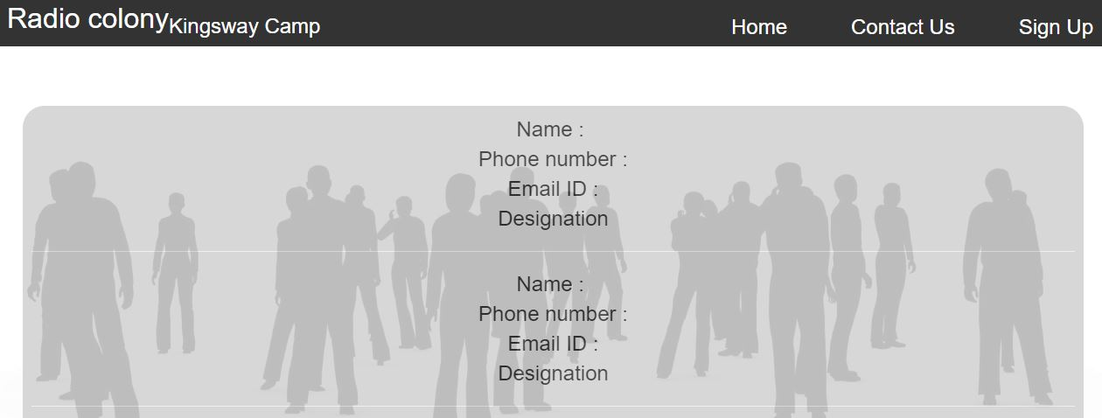

3.4 Complaint

<%@ Page Language="C#" AutoEventWireup="true" CodeBehind="complaint.aspx.cs" Inherits="WebApplication2.login" MasterPageFile="~/Site1.Master"%>

<asp:Content ID="head" ContentPlaceHolderID="headcontent" runat="server">

<style>

.div

{

background-color:lightgrey;

margin:2vw;

opacity:0.9;

height:100%;

padding:30px;

font-size:x-large;

text-align:center;

}

.click

{

font-size:xx-large;

padding:1vw;

margin-left:3vw;

border-radius:25px;

}

.click1

{

font-size:x-large;

padding:1vw;

margin-left:3vw;

border-radius:25px;

}

#TextBox1

{

height:500px;

width:500px;

}

@media screen and (max-width: 500px )

{

.click

{

font-size:x-large;

padding:1vw;

margin-left:3vw;

margin-bottom:3vw;

border-radius:25px;

}

.heading1

{

font-size:x-large;

}

}

</style>

</asp:Content>

<asp:Content ID="main" ContentPlaceHolderID="maincontent" runat="server">

<div class="div">

<asp:Button ID="Button1" CssClass="click" runat="server" Text="Pending Complaints" CausesValidation="False" />

<asp:Button ID="Button2" CssClass="click" runat="server" Text="All Complaints" CausesValidation="False" OnClick="Button2_Click" />

<h1 class="heading1" style="text-decoration:underline;margin-top:3vw;">Register Complaint</h1>

<table style="width:70%; align-content:center;">

<tr>

<td style="align-content:flex-end; float:right">

Complaint Type:

</td>

<td >

<asp:DropDownList ID="ddlcomtype" runat="server" style="margin-left:2vw;" OnSelectedIndexChanged="DropDownList1_SelectedIndexChanged" Font-Size="Large"></asp:DropDownList>

<asp:RequiredFieldValidator ID="RequiredFieldValidator3" runat="server" ErrorMessage="complaint type" ForeColor="Red" ControlToValidate="ddlcomtype"></asp:RequiredFieldValidator>

</td>

</tr>

<tr>

<td>

<br />

</td>

</tr>

<tr>

<td>

<br />

</td>

</tr>

<tr>

<td style="align-content:flex-end;">

<asp:Label ID="Label1" runat="server" Text="Description" style="padding-right:10vw;"></asp:Label>

</td>

<td >

<asp:TextBox ID="TextBox1" runat="server" TextMode="MultiLine" Height="220" Width="350"></asp:TextBox>

<asp:RegularExpressionValidator Display = "Dynamic" ControlToValidate = "TextBox1" ID="RegularExpressionValidator1" ValidationExpression = "^[\s\S]{0,350}$" runat="server" ErrorMessage="Maximum 350 characters allowed." ForeColor="Red"></asp:RegularExpressionValidator>

<asp:RequiredFieldValidator ID="RequiredFieldValidator4" runat="server" ControlToValidate="TextBox1" ErrorMessage="Description Reqd!!" ForeColor="Red"></asp:RequiredFieldValidator>

</td>

</tr>

</table>

<asp:Button ID="Button3" CssClass="click1" runat="server" Text="Register" OnClick="Button3_Click" />

<asp:Button ID="Button4" CssClass="click1" runat="server" Text="Cancel" OnClick="Button4_Click" CausesValidation="False" />

</div>

</asp:Content>

C# code:

using System;

using System.Collections.Generic;

using System.Linq;

using System.Web;

using System.Web.UI;

using System.Web.UI.WebControls;

using System.Web.Configuration;

using System.Configuration;

using System.Data.SqlClient;

using System.Data;

namespace WebApplication2

{

public partial class login : System.Web.UI.Page

{

protected void Page_Load(object sender, EventArgs e)

{

if (Convert.ToInt32(Session["validloginflag"]) != 1)

{

Response.Redirect("home.aspx");

}

else

{

if (!IsPostBack)

{

binddropdown();

}

}

}

private void binddropdown()

{

String conf = WebConfigurationManager.ConnectionStrings["con"].ConnectionString;

SqlConnection conn = new SqlConnection(conf);

conn.Open();

DataTable dt = new DataTable();

SqlCommand cmd = new SqlCommand("sp_complaint_type", conn);

cmd.CommandType = CommandType.StoredProcedure;

cmd.Parameters.AddWithValue("@flag", 1);

SqlDataAdapter da = new SqlDataAdapter(cmd);

da.Fill(dt);

ddlcomtype.DataSource = dt;

ddlcomtype.DataValueField = "c_id";

ddlcomtype.DataTextField = "c_type";

ddlcomtype.DataBind();

}

protected void DropDownList1_SelectedIndexChanged(object sender, EventArgs e)

{

}

protected void Button3_Click(object sender, EventArgs e)

{

String conf = WebConfigurationManager.ConnectionStrings["con"].ConnectionString;

SqlConnection conn = new SqlConnection(conf);

conn.Open();

//DataSet ds = new DataSet();

//SqlDataAdapter da = new SqlDataAdapter();

SqlCommand cmd = new SqlCommand("sp_reg_complaint", conn);

cmd.CommandType = CommandType.StoredProcedure;

cmd.Parameters.AddWithValue("@ctypeid", Convert.ToInt16(ddlcomtype.SelectedItem.Value));

cmd.Parameters.AddWithValue("@c_des", TextBox1.Text);

cmd.Parameters.AddWithValue("@flag",1);

cmd.Parameters.AddWithValue("@r_id", Convert.ToInt32(Session["candidateid"]));

cmd.Parameters.Add("@compidout", SqlDbType.Int);

cmd.Parameters["@compidout"].Direction = ParameterDirection.Output;

int i = cmd.ExecuteNonQuery();

conn.Close();

if (i > 0)

{

ScriptManager.RegisterStartupScript(this, this.GetType(), "Script", "alert('Complaint Registered Successfully')", true);

}

TextBox1.Text = "";

}

protected void Button4_Click(object sender, EventArgs e)

{

Response.Redirect("complaint.aspx");

//move to the next link i.e default.aspx

}

protected void Button2_Click(object sender, EventArgs e)

{

Response.Redirect("AllComplaints.aspx");

}

}

}

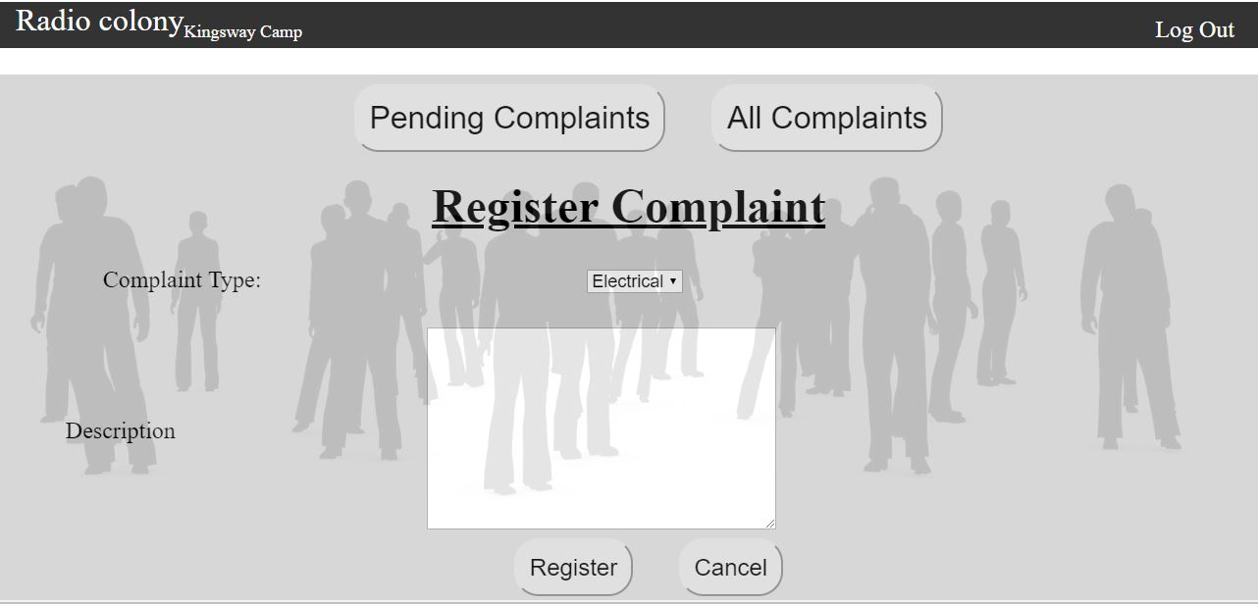

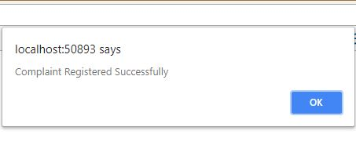

3.5 All complaint

<%@ Page Language="C#" AutoEventWireup="true" CodeBehind="AllComplaints.aspx.cs" Inherits="WebApplication2.AllComplaints" MasterPageFile="~/Site1.Master" %>

<asp:Content ID="head" ContentPlaceHolderID="headcontent" runat="server">

<meta charset="utf-8" />

<meta name="viewport" content="width=device-width, initial-scale=1" />

<link rel="stylesheet" href="https://maxcdn.bootstrapcdn.com/bootstrap/3.3.7/css/bootstrap.min.css" />

<script src="https://ajax.googleapis.com/ajax/libs/jquery/3.3.1/jquery.min.js"></script>

<script src="https://maxcdn.bootstrapcdn.com/bootstrap/3.3.7/js/bootstrap.min.js"></script>

<style>

.div {

background-color: lightgrey;

margin: 2vw;

opacity: 0.9;

height: 100%;

padding: 30px;

font-size: x-large;

text-align: center;

}

.click {

font-size: xx-large;

padding: 1vw;

margin-left: 3vw;

border-radius: 25px;

}

.click1 {

font-size: x-large;

padding: 1vw;

margin-left: 3vw;

border-radius: 25px;

}

</style>

</asp:Content>

<asp:Content ID="main" ContentPlaceHolderID="maincontent" runat="server">

<asp:Button ID="Button1" runat="server" Text="Back" OnClick="Button1_Click" Style="text-align: center; padding: 2vw;

margin: 3vw; font-size: xx-large; float: right; border-radius: 25px;" />

<div id="divprimary" runat="server" visible="true">

<asp:GridView ID="grdcomdetails" runat="server" AutoGenerateColumns="False" EmptyDataText="..No Records Found.." HorizontalAlign="Center" PageSize="20"

ShowHeaderWhenEmpty="True" ToolTip="Complaints and their Status" OnPageIndexChanging="grdcomdetails_PageIndexChanging" OnRowCommand="grdcomdetails_RowCommand"

BackColor="#CCCCCC" Width="70%">

<HeaderStyle BackColor="#0099FF" Font-Bold="True" ForeColor="Black" />

<Columns>

<asp:TemplateField HeaderText="S.No.">

<ItemTemplate>

<asp:Label ID="lblSNo" runat="server" Text='<%#Container.DataItemIndex+1 %>' />

</ItemTemplate>

</asp:TemplateField>

<asp:TemplateField HeaderText="Complaint-Type">

<ItemTemplate>

<asp:Label ID="lblcompfor" runat="server" Text='<%#Eval("compfor") %>' Font-Size="Smaller" />

</ItemTemplate>

</asp:TemplateField>

<asp:TemplateField HeaderText="Complaint Description">

<ItemTemplate>

<asp:Label ID="lblcompdesc" runat="server" Text='<%#Eval("c_des") %>' Font-Size="Smaller" />

</ItemTemplate>

</asp:TemplateField>

<asp:TemplateField HeaderText="Complaint registered On">

<ItemTemplate>

<asp:Label ID="lblregon" runat="server" Text='<%#Eval("comp_dt_create") %>' Font-Size="Smaller" />

</ItemTemplate>

</asp:TemplateField>

<asp:TemplateField HeaderText="Status">

<ItemTemplate>

<asp:LinkButton ID="lnkstatus" CommandName="statusdetails" runat="server" Text='<%#Eval("comp_status_type") %>'

Font-Size="Smaller" class="btn btn-info btn-lg"></asp:LinkButton>

<asp:Label ID="lblcompid" runat="server" Text='<%#Eval("comp_id") %>' Visible="false"></asp:Label>

</ItemTemplate>

</asp:TemplateField>

</Columns>

</asp:GridView>

</div>

<div id="divsecondary" runat="server" visible="false">

<asp:GridView ID="grd2" runat="server" AutoGenerateColumns="False" EmptyDataText="..No Records Found.." HorizontalAlign="Center" PageSize="20"

ShowHeaderWhenEmpty="True" ToolTip="Detailed Status" OnPageIndexChanging="grdcomdetails_PageIndexChanging" OnRowCommand="grdcomdetails_RowCommand"

BackColor="#CCCCCC" Width="70%">

<HeaderStyle BackColor="#0099FF" Font-Bold="True" ForeColor="Black" />

<Columns>

<asp:TemplateField HeaderText="S.No.">

<ItemTemplate>

<asp:Label ID="lblSNo" runat="server" Text='<%#Container.DataItemIndex+1 %>' />

</ItemTemplate>

</asp:TemplateField>

<asp:TemplateField HeaderText="Complaint-Type">

<ItemTemplate>

<asp:Label ID="lblofficerid" runat="server" Text='<%#Eval("comp_id") %>' Font-Size="Smaller" />

</ItemTemplate>

</asp:TemplateField>

<asp:TemplateField HeaderText="Officer ">

<ItemTemplate>

<asp:Label ID="lbloff" runat="server" Text='<%#Eval("officername") %>' Font-Size="Smaller" />

</ItemTemplate>

</asp:TemplateField>

<asp:TemplateField HeaderText="Complaint forwarded to">

<ItemTemplate>

<asp:Label ID="lblcompforto" runat="server" Text='<%#Eval("forwardtowhom") %>' Font-Size="Smaller" />

</ItemTemplate>

</asp:TemplateField>

<asp:TemplateField HeaderText="Status flag ">

<ItemTemplate>

<asp:Label ID="lblstatus" runat="server" Text='<%#Eval("statusflag") %>' Visible="false"></asp:Label>

</ItemTemplate>

</asp:TemplateField>

<asp:TemplateField HeaderText="remarks ">

<ItemTemplate>

<asp:Label ID="lblremarks" runat="server" Text='<%#Eval("remarks") %>' Font-Size="Smaller" />

</ItemTemplate>

</asp:TemplateField>

<asp:TemplateField HeaderText="datestamp ">

<ItemTemplate>

<asp:Label ID="lblds" runat="server" Text='<%#Eval("DateStamp") %>' Font-Size="Smaller" />

</ItemTemplate>

</asp:TemplateField>

</Columns>

</asp:GridView>

<asp:Button ID="closedivs" runat="server" Text="close" Style="text-align: center; padding: 2vw;

margin: 3vw; font-size: xx-large; float: right; border-radius: 25px;" OnClick="closedivs_Click" />

</div>

</asp:Content>

C# code:

using System;

using System.Collections.Generic;

using System.Linq;

using System.Web;

using System.Web.UI;

using System.Web.UI.WebControls;

using System.Web.Configuration;

using System.Configuration;

using System.Data.SqlClient;

using System.Data;

namespace WebApplication2

{

public partial class AllComplaints : System.Web.UI.Page

{

protected void Page_Load(object sender, EventArgs e)

{

if (Convert.ToInt32(Session["validloginflag"]) != 1)

{

Response.Redirect("home.aspx");

}

else

{

if (!IsPostBack)

{

bindgrd();

}

}

}

private void bindgrd()

{

String conf = WebConfigurationManager.ConnectionStrings["con"].ConnectionString;

SqlConnection conn = new SqlConnection(conf);

conn.Open();

DataTable dt = new DataTable();

SqlCommand cmd = new SqlCommand("sp_reg_complaint", conn);

cmd.CommandType = CommandType.StoredProcedure;

cmd.Parameters.AddWithValue("@flag", 5);

cmd.Parameters.AddWithValue("@r_id", Convert.ToInt32(Session["candidateid"]));

SqlDataAdapter da = new SqlDataAdapter(cmd);

da.Fill(dt);

grdcomdetails.DataSource = dt;

grdcomdetails.DataBind();

}

protected void Button1_Click(object sender, System.EventArgs e)

{

Response.Redirect("complaint.aspx");

}

protected void grdcomdetails_PageIndexChanging(object sender, GridViewPageEventArgs e)

{

grdcomdetails.PageIndex = e.NewPageIndex;

bindgrd();

}

protected void grdcomdetails_RowCommand(object sender, GridViewCommandEventArgs e)

{

//statusdetails

if (e.CommandName == "statusdetails")

{

GridViewRow gvRow = (GridViewRow)(((LinkButton)e.CommandSource).NamingContainer);

Label lblcompidd = (Label)gvRow.FindControl("lblcompid");

//Session["compid"] = lblcompidd.Text;

bindgrd2(Convert.ToInt32(lblcompidd.Text));

divprimary.Visible = false;

divsecondary.Visible = true;

}

}

private void bindgrd2(int x)

{

String conf = WebConfigurationManager.ConnectionStrings["con"].ConnectionString;

SqlConnection conn = new SqlConnection(conf);

conn.Open();

DataTable dt = new DataTable();

SqlCommand cmd = new SqlCommand("sp_reg_complaint", conn);

cmd.CommandType = CommandType.StoredProcedure;

cmd.Parameters.AddWithValue("@flag", 6);

cmd.Parameters.AddWithValue("@compid", x);

SqlDataAdapter da = new SqlDataAdapter(cmd);

da.Fill(dt);

grd2.DataSource = dt;

grd2.DataBind();

}

protected void closedivs_Click(object sender, EventArgs e)

{

divprimary.Visible = true;

divsecondary.Visible = false;

}

}

}

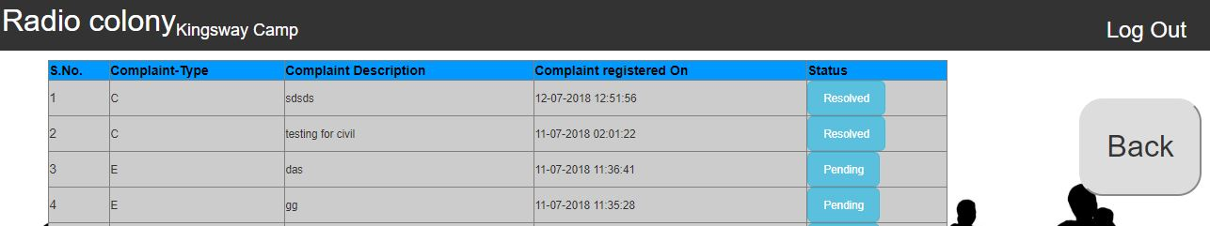

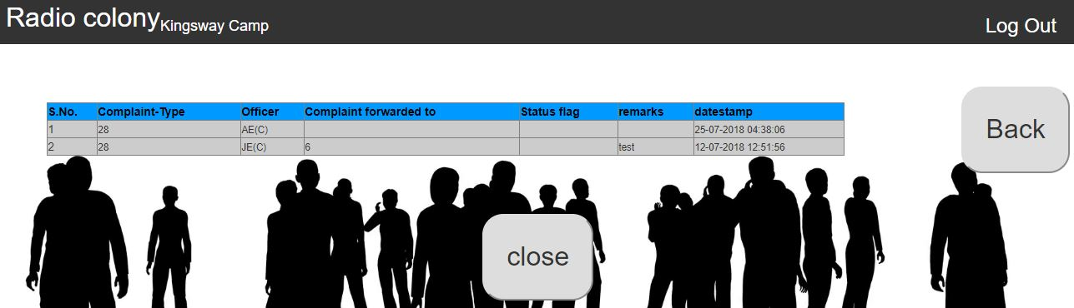

3.6 Complaint Status

<%@ Page Language="C#" AutoEventWireup="true" CodeBehind="CompliantStatus.aspx.cs" Inherits="WebApplication2.CompliantStatus" EnableEventValidation="false" Culture="en-GB" %>

<!DOCTYPE html>

<html xmlns="http://www.w3.org/1999/xhtml" lang="en">

<head runat="server">

<title></title>

<meta name="viewport" content="width=device-width, initial-scale=1" />

<meta charset="utf-8" />

<!-- Latest compiled and minified CSS -->

<link rel="stylesheet" href="https://maxcdn.bootstrapcdn.com/bootstrap/3.3.7/css/bootstrap.min.css" />

<!-- jQuery library -->

<script src="https://ajax.googleapis.com/ajax/libs/jquery/3.3.1/jquery.min.js"></script>

<!-- Latest compiled JavaScript -->

<script src="https://maxcdn.bootstrapcdn.com/bootstrap/3.3.7/js/bootstrap.min.js"></script>

<script type="text/javascript">

function MutExChkList(chk) {

var chkList = chk.parentNode.parentNode.parentNode;

var chks = chkList.getElementsByTagName("input");

for (var i = 0; i < chks.length; i++) {

if (chks[i] != chk && chk.checked) {

chks[i].checked = false;

}

}

}

function MouseEvents(objRef, evt) {

if (evt.type == "mouseover") {

objRef.style.cursor = 'default';

objRef.style.backgroundColor = "red";

}

else {

if (evt.type == "mouseout") objRef.style.backgroundColor = "#F7F7F7";

}

}

</script>

<style>

.button0 {

padding: 1vw;

font-size: x-large;

margin-left: 25vw;

border-radius: 25px;

background-color: #4cb2fb;

color: white;

}

.drop {

font-size: x-large;

text-align: center;

margin-top: 2vw;

}

ul {

list-style-type: none;

margin: 0;

padding: 0;

overflow: hidden;

background-color: #333;

text-decoration: none;

position: relative;

}

li {

float: right;

}

li a {

display: block;

color: white;

text-align: center;

padding: 5px 16px;

margin-right: 3vw;

text-decoration: none;

font-size: x-large;

height: 44px;

}

li a:hover {

background-color: #111;

}

.logo {

float: left;

display: block;

color: white;

text-align: center;

margin-left: 50px;

font-size: xx-large;

text-decoration: none;

}

#divbody {

background-repeat: no-repeat;

background-position: top;

background-size: cover;

background-image: url('images/society6.png');

width: 100%;

}

.container1 {

align-content: center;

background-color: lightgrey;

width: 96%;

padding: 40px;

text-align: center;

align-content: center;

align-self: center;

margin: 2vw;

}

.container2 {

background-color: darkgrey;

width: 96%;

padding: 40px;

margin: 2vw;

}

.forward {

text-align: center;

margin: 5vw;

opacity: 0.9;

}

</style>

</head>

<body id="divbody">

<form id="form1" runat="server">

<ul>

<li class="logo">Radio colony<sub class="size">Kingsway Camp</sub></li>

<li><a>

<asp:LinkButton ID="LinkButton1" runat="server" OnClick="LinkButton1_Click">Log out</asp:LinkButton></a></li>

</ul>

<div class="drop">

<asp:Label ID="Label1" runat="server" Text="Complaint Status" Style="margin-right: 2vw;"></asp:Label>

<asp:DropDownList ID="DropDownList1" runat="server" Style="font-size: x-large;" AutoPostBack="True" OnSelectedIndexChanged="DropDownList1_SelectedIndexChanged"></asp:DropDownList>

</div>

<div id="divcomgrd" runat="server" visible="true" class="container1">

<asp:GridView ID="grdcomdetails" runat="server" AutoGenerateColumns="False" EmptyDataText="..No Records Found.." HorizontalAlign="Center"

PageSize="20" ShowHeaderWhenEmpty="True" ToolTip="Complaints and their Status"

OnPageIndexChanging="grdcomdetails_PageIndexChanging" OnRowDataBound="grdcomdetails_RowDataBound" OnSelectedIndexChanged="grdcomdetails_SelectedIndexChanged">

<HeaderStyle BackColor="#0099FF" Font-Bold="True" ForeColor="Black" HorizontalAlign="Center" />

<Columns>

<asp:TemplateField HeaderText="S.No.">

<ItemTemplate>

<asp:Label ID="lblSNo" runat="server" Text='<%#Container.DataItemIndex+1 %>' />

</ItemTemplate>

</asp:TemplateField>

<asp:TemplateField HeaderText="description">

<ItemTemplate>

<asp:Label ID="lbldesc" runat="server" Text='<%#Eval("c_des") %>' />

</ItemTemplate>

</asp:TemplateField>

<%-- <asp:TemplateField HeaderText="officer">

<ItemTemplate>

<asp:Label ID="lblofc" runat="server" Text='<%#Eval("officer") %>' />

</ItemTemplate>

</asp:TemplateField>--%>

<asp:TemplateField HeaderText="remarks">

<ItemTemplate>

<asp:Label ID="lblrem" runat="server" Text='<%#Eval("remarks") %>' />

</ItemTemplate>

</asp:TemplateField>

<asp:TemplateField HeaderText="Date">

<ItemTemplate>

<asp:Label ID="lbldt" runat="server" Text='<%#Eval("DateStamp") %>' />

</ItemTemplate>

</asp:TemplateField>

<asp:TemplateField HeaderText="status">

<ItemTemplate>

<asp:Label ID="lblsts" runat="server" CommandName="statusdetails" Font-Bold="true" Text='<%#Eval("comp_status_type") %>'></asp:Label>

<asp:Label ID="lblcompid" runat="server" Visible="false" Text='<%#Eval("comp_id") %>' />

<asp:Label ID="lbltrcomid" runat="server" Visible="false" Text='<%#Eval("tr_com_id") %>' />

</ItemTemplate>

</asp:TemplateField>

<asp:TemplateField HeaderText="Final Status">

<ItemTemplate>

<asp:Label ID="lblfinal" runat="server" Visible="true" Text='<%#Eval("final") %>' />

<asp:Label ID="lblfinalstatus" runat="server" Visible="false" Text='<%#Eval("finalstatus") %>' />

<br />

Date:

<asp:Label ID="lblresolvedon" runat="server" Visible="true" Text='<%#Eval("resolvedon") %>' />

<br />

ResolvedBy:

<asp:Label ID="lblresolvedby" runat="server" Visible="true" Text='<%#Eval("resolvedby_offid") %>' />

</ItemTemplate>

</asp:TemplateField>

</Columns>

</asp:GridView>

<div id="divresorfor" runat="server" visible="false" align="center" style="padding: 10px" class="container2">

<asp:CheckBoxList ID="CheckBoxList1" runat="server" AutoPostBack="True" CellPadding="2"

CellSpacing="2" OnSelectedIndexChanged="CheckBoxList1_SelectedIndexChanged">

<asp:ListItem Value="1">Resolved</asp:ListItem>

<asp:ListItem Value="3">Forward</asp:ListItem>

</asp:CheckBoxList>

</div>

</div>

<div id="divsearch" runat="server" visible="false" align="center">

<asp:Button ID="btnsearch" runat="server" Text="Search" CssClass="button0" />

</div>

<div id="divsubmit" runat="server" visible="false" align="center">

<asp:Button ID="Button1" runat="server" Text="Submit Status" OnClick="Button1_Click" />

</div>

<div id="divforward" runat="server" visible="false " align="center">

<asp:DropDownList ID="ddloftype" runat="server" align ="center" OnSelectedIndexChanged="DropDownList2_SelectedIndexChanged" Font-Size="Large"></asp:DropDownList>

<asp:RequiredFieldValidator ID="RequiredFieldValidator3" runat="server" ErrorMessage="complaint type" ForeColor="Red" ControlToValidate="ddloftype"></asp:RequiredFieldValidator>

<br />

<asp:TextBox ID="TextBox1" runat="server" Style="height: 10vw; width: 20vw; background-color: lightgrey;" TextMode="MultiLine"></asp:TextBox>

<br />

<asp:Button ID="Button3" runat="server" Text="Forward" OnClick="Button3_Click" />

</div>

</form>

</body>

</html>

C#code

using System;

using System.Collections.Generic;

using System.Linq;

using System.Web;

using System.Web.UI;

using System.Web.UI.WebControls;

using System.Web.Configuration;

using System.Configuration;

using System.Data.SqlClient;

using System.Data;

using System.Drawing;

namespace WebApplication2

{

public partial class CompliantStatus : System.Web.UI.Page

{

protected void Page_Load(object sender, EventArgs e)

{

if (Convert.ToInt32(Session["validloginflag"]) != 1)

{

Response.Redirect("home.aspx");

}

else

{

for (int i = 0; i < CheckBoxList1.Items.Count; i++)

{

CheckBoxList1.Items[i].Attributes.Add("onclick", "MutExChkList(this)");

}

if (!IsPostBack)

{

binddropdown();

bindgrd(0, 2);

binddropdown2();

}

}

}

private void bindgrd(int s, int f)

{

String conf = WebConfigurationManager.ConnectionStrings["con"].ConnectionString;

SqlConnection conn = new SqlConnection(conf);

conn.Open();

DataTable dt = new DataTable();

SqlCommand cmd = new SqlCommand("sp_trn_complaint", conn);

cmd.CommandType = CommandType.StoredProcedure;

cmd.Parameters.AddWithValue("@flag", f);

cmd.Parameters.AddWithValue("@officerid", Convert.ToInt32(Session["loginofficerid"]));

cmd.Parameters.AddWithValue("@statusflag", s);

SqlDataAdapter da = new SqlDataAdapter(cmd);

da.Fill(dt);

grdcomdetails.DataSource = dt;

grdcomdetails.DataBind();

}

private void binddropdown()

{

String conf = WebConfigurationManager.ConnectionStrings["con"].ConnectionString;

SqlConnection conn = new SqlConnection(conf);

conn.Open();

DataTable dt = new DataTable();

SqlCommand cmd = new SqlCommand("sp_complaint_status_type", conn);

cmd.CommandType = CommandType.StoredProcedure;

cmd.Parameters.AddWithValue("@flag", 1);

SqlDataAdapter da = new SqlDataAdapter(cmd);

da.Fill(dt);

DropDownList1.DataSource = dt;

DropDownList1.DataValueField = "comp_status_id";

DropDownList1.DataTextField = "comp_status_type";

DropDownList1.DataBind();

}

private void binddropdown2()

{

String conf = WebConfigurationManager.ConnectionStrings["con"].ConnectionString;

SqlConnection conn = new SqlConnection(conf);

conn.Open();

DataTable dt = new DataTable();

SqlCommand cmd = new SqlCommand("SP_Officer", conn);

cmd.CommandType = CommandType.StoredProcedure;

cmd.Parameters.AddWithValue("@flag", 1);

cmd.Parameters.AddWithValue("@usertypeid", Convert.ToInt32(Session["usertype"]));

SqlDataAdapter da = new SqlDataAdapter(cmd);

da.Fill(dt);

ddloftype.DataSource = dt;

ddloftype.DataValueField = "officerid";

ddloftype.DataTextField = "Officer";

ddloftype.DataBind();

}

protected void DropDownList2_SelectedIndexChanged(object sender, EventArgs e)

{

}

protected void LinkButton1_Click(object sender, EventArgs e)

{

Session.Clear();

Session.Abandon();

Response.Redirect("home.aspx");

}

protected void DropDownList1_SelectedIndexChanged(object sender, EventArgs e)

{

bindgrd(Convert.ToInt16(DropDownList1.SelectedValue), 3);

}

protected void grdcomdetails_PageIndexChanging(object sender, GridViewPageEventArgs e)

{

grdcomdetails.PageIndex = e.NewPageIndex;

}

protected void CheckBoxList1_SelectedIndexChanged(object sender, EventArgs e)

{

//divresorfor.Visible = true;

if (CheckBoxList1.SelectedValue == "1")

{

divsubmit.Visible = true;

divforward.Visible = false;

}

else if (CheckBoxList1.SelectedValue == "3")

{

divforward.Visible = true;

divsubmit.Visible = false;

}

else

{

divforward.Visible = false;

divsubmit.Visible = false;

}

}

protected void grdcomdetails_SelectedIndexChanged(object sender, EventArgs e)

{

GridViewRow row1 = grdcomdetails.Rows[grdcomdetails.SelectedIndex];

Label chk = (Label)row1.FindControl("lblcompid");

ViewState["lblcompid"] = chk.Text;

Label lblsts = (Label)row1.FindControl("lblsts");

Label lbltrcomid = (Label)row1.FindControl("lbltrcomid");

ViewState["trcomid"] = lbltrcomid.Text;

Label lblfinalstatus = (Label)row1.FindControl("lblfinalstatus");

ViewState["lblfinalstatus"] = lblfinalstatus.Text;

//Session["compid"] = lblcompidd.Text;

if (lblsts.Text == "Pending" && !Convert.ToBoolean(ViewState["lblfinalstatus"]))

divresorfor.Visible = true;

else if (lblsts.Text == "Forwarded" && !Convert.ToBoolean(ViewState["lblfinalstatus"]))

{

divresorfor.Visible = false;

ScriptManager.RegisterStartupScript(this, this.GetType(), "Script", "alert('Complaint has been Forwarded!!!!!!')", true);

}

else

{

divresorfor.Visible = false;

ScriptManager.RegisterStartupScript(this, this.GetType(), "Script", "alert('Complaint has been resolved!!!!!!')", true);

}

foreach (GridViewRow row in grdcomdetails.Rows)

{

if (row.RowIndex == grdcomdetails.SelectedIndex)

{

row.BackColor = ColorTranslator.FromHtml("#A1DCF2");

row.ToolTip = string.Empty;

}

else

{

row.BackColor = ColorTranslator.FromHtml("#FFFFFF");

row.ToolTip = "Click to select this row.";

}

}

}

protected void grdcomdetails_RowDataBound(object sender, GridViewRowEventArgs e)

{

if (e.Row.RowType == DataControlRowType.DataRow)

{

e.Row.Attributes["onclick"] = Page.ClientScript.GetPostBackClientHyperlink(grdcomdetails, "Select$" + e.Row.RowIndex);

e.Row.ToolTip = "Click to select this row.";

e.Row.Attributes.Add("onmouseover", "MouseEvent(this, event)");

e.Row.Attributes.Add("onmouseout", "MouseEvent(this, event)");

//ImageButton imgbtnUpdate = (ImageButton)e.Row.FindControl("imgbtnUpdate");

}

}

protected void Button3_Click(object sender, EventArgs e)

{

String conf = WebConfigurationManager.ConnectionStrings["con"].ConnectionString;

SqlConnection conn = new SqlConnection(conf);

conn.Open();

//DataSet ds = new DataSet();

//SqlDataAdapter da = new SqlDataAdapter();

SqlCommand cmd = new SqlCommand("sp_trn_complaint", conn);

cmd.CommandType = CommandType.StoredProcedure;

cmd.Parameters.AddWithValue("@forwardtowhom", Convert.ToInt16(ddloftype.SelectedItem.Value));

cmd.Parameters.AddWithValue("@remarks", TextBox1.Text.Trim());

cmd.Parameters.AddWithValue("@flag", 4);

cmd.Parameters.AddWithValue("@tr_com_id", Convert.ToInt32(ViewState["trcomid"]));

cmd.Parameters.AddWithValue("@comp_id", Convert.ToInt32(ViewState["lblcompid"]));

int i = cmd.ExecuteNonQuery();

conn.Close();

if (i > 0)

{

ScriptManager.RegisterStartupScript(this, this.GetType(), "Script", "alert('Complaint forwarded Successfully')", true);

bindgrd(0, 2);

divforward.Visible = false;

divsubmit.Visible = false;

divresorfor.Visible = false;

}

TextBox1.Text = "";

}

protected void Button1_Click(object sender, EventArgs e)

{

String conf = WebConfigurationManager.ConnectionStrings["con"].ConnectionString;

SqlConnection conn = new SqlConnection(conf);

conn.Open();

SqlCommand cmd = new SqlCommand("sp_trn_complaint", conn);

cmd.CommandType = CommandType.StoredProcedure;

cmd.Parameters.AddWithValue("@officerid", Convert.ToInt32(Session["loginofficerid"]));

//cmd.Parameters.AddWithValue("@remarks", TextBox1.Text.Trim());

cmd.Parameters.AddWithValue("@flag", 5);

cmd.Parameters.AddWithValue("@tr_com_id", Convert.ToInt32(ViewState["trcomid"]));

cmd.Parameters.AddWithValue("@comp_id", Convert.ToInt32(ViewState["lblcompid"]));

int i = cmd.ExecuteNonQuery();

conn.Close();

if (i > 0)

{

ScriptManager.RegisterStartupScript(this, this.GetType(), "Script", "alert('Complaint resolved Successfully')", true);

bindgrd(0, 2);

divforward.Visible = false;

divsubmit.Visible = false;

divresorfor.Visible = false;

}

TextBox1.Text = "";

}

}

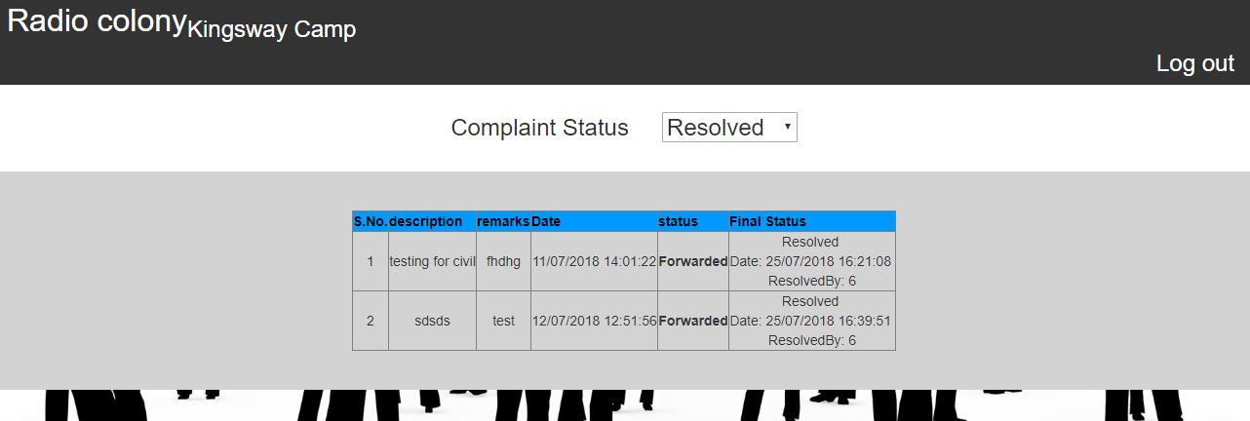

Sql stored procedure

USE [rwa]

GO

/****** Object: StoredProcedure [dbo].[sp_complaint_status] Script Date: 27-07-2018 03:11:21 ******/

SET ANSI_NULLS ON

GO

SET QUOTED_IDENTIFIER ON

GO

ALTER proc [dbo].[sp_complaint_status]

(

@statusid int=null,

@compid varchar(50)=null,

@flag int

)

as

begin

if(@flag=1)

begin

Select * from complaint_type

end

end

USE [rwa]

GO

/****** Object: StoredProcedure [dbo].[sp_complaint_status_type] Script Date: 27-07-2018 03:11:47 ******/

SET ANSI_NULLS ON

GO

SET QUOTED_IDENTIFIER ON

GO

ALTER proc [dbo].[sp_complaint_status_type]

(

@comp_status_id int=null,

@comp_status_type varchar(50)=null,

@flag int

)

as

begin

if(@flag=1)

begin

Select * from comp_status_type

end

end

USE [rwa]

GO

/****** Object: StoredProcedure [dbo].[sp_complaint_type] Script Date: 27-07-2018 03:12:05 ******/

SET ANSI_NULLS ON

GO

SET QUOTED_IDENTIFIER ON

GO

ALTER proc [dbo].[sp_complaint_type]

(

@c_id int=null,

@c_type varchar(50)=null,

@flag int

)

as

begin

if(@flag=1)

begin

Select * from complaint_type

end

end

USE [rwa]

GO

/****** Object: StoredProcedure [dbo].[SP_Officer] Script Date: 27-07-2018 03:12:21 ******/

SET ANSI_NULLS ON

GO

SET QUOTED_IDENTIFIER ON

GO

ALTER Proc [dbo].[SP_Officer]

(

@officerid int=null,

@Officer nvarchar(500)=null,

@usertypeid int=null,

@srno int=null,

@flag int

)

as

if(@flag=1)

begin

begin

select * from Officer where usertypeid=@usertypeid

end

end

USE [rwa]

GO

/****** Object: StoredProcedure [dbo].[sp_reg_complaint] Script Date: 27-07-2018 03:12:44 ******/

SET ANSI_NULLS ON

GO

SET QUOTED_IDENTIFIER ON

GO

ALTER proc [dbo].[sp_reg_complaint]

(

@compid int=null,

@ctypeid int=null,

@r_id int=null,

@c_des nvarchar(350)=null,

@regdt datetime=null,

@compidout int=null output,

@flag int

)

as

begin

if(@flag=1)

begin

Declare @officerid int,

@c_typeid int;

begin try

begin transaction

Insert into complaint (ctype_id,r_id,c_des,comp_dt_create) values (@ctypeid,@r_id,@c_des,getdate())

select @compidout=SCOPE_IDENTITY()

select @c_typeid=ctype_id from complaint where comp_id=@compidout

if(@c_typeid=1)

begin

select @officerid=1

end

else

begin

select @officerid=5

end

insert into trn_complaint (comp_id,officerid,statusflag,serialno,DateStamp) values (@compidout,@officerid,2,1,getdate())

Commit

end try

begin catch

if @@TRANCOUNT>0

RollBack

end catch

end

if(@flag=2)

begin

Select * from complaint where r_id=@r_id

end

if(@flag=3)

begin

Select @compidout=max(comp_id) from complaint where r_id=@r_id

end

if (@flag =4)

begin

insert into trn_complaint (comp_id,officerid,statusflag,serialno,DateStamp) values (@compidout,@officerid,3,1,getdate())

end

if(@flag=5)

begin

Select cmp.comp_id,cmp.ctype_id,ut.[type] as compfor,cmp.r_id,(reg.[Name]+'-'+reg.Designation)as r_name,cmp.c_des,comp_dt_create,cmp.resolved_flag,st.comp_status_type

from complaint as cmp

left join Usertype ut on ut.ccwuserid=cmp.ctype_id

left join registration as reg on reg.R_id=cmp.r_id

left join comp_status_type as st on st.comp_status_id=cmp.resolved_flag

where cmp.r_id=@r_id

order by comp_dt_create desc

end

if (@flag=6)

begin

Select tc.tr_com_id,tc.comp_id,tc.officerid,ofc.Officer as officername,tc.statusflag,st.comp_status_type,forwardtowhom,

tc.remarks,tc.serialno,tc.DateStamp from trn_complaint as tc

left join Officer as ofc on ofc.officerid=tc.officerid

left join comp_status_type as st on st.comp_status_id=tc.statusflag

where tc.comp_id=@compid

order by tc.DateStamp desc

end

end

USE [rwa]

GO

/****** Object: StoredProcedure [dbo].[SP_registration] Script Date: 27-07-2018 03:13:08 ******/

SET ANSI_NULLS ON

GO

SET QUOTED_IDENTIFIER ON

GO

ALTER proc [dbo].[SP_registration]

(

@name nvarchar(50)=null,

@dob varchar(20) =null,

@mob numeric(10,0)=null,

@mob_flag bit =null,

@Email_ID nvarchar(30) =null,

@em_flag bit =null,

@Office nvarchar(150) =null,

@Designation nvarchar(100) =null,

@Blood_Group nvarchar(4) =null,

@Flat_type char(2) =null,

@Block_no varchar(5) =null,

@Flat_no int =null,

@no_family int =null,

@password varchar(50) =null,

@Uploadfilename nvarchar(50) =null,

@flag int

)

as

begin

if(@flag=1)--insert

begin

Insert into registration ([Name],Date_Of_Birth,Mobile,Email_ID,Office,Designation,Blood_Group,Flat_type,Block_no,Flat_no,no_family,[password],

Uploadfilename) values(@name,@dob,@mob,@Email_ID,@Office,@Designation,@Blood_Group,@Flat_type,@Block_no,@Flat_no,@no_family,@password,@Uploadfilename)

end

If(@flag=2)

begin

Select Email_ID,[password],verifyuserflag,R_id,ccwUsertype,officer_id from registration where Email_ID=@Email_ID and verifyuserflag=1

end

end

USE [rwa]

GO

/****** Object: StoredProcedure [dbo].[sp_trn_complaint] Script Date: 27-07-2018 03:13:26 ******/

SET ANSI_NULLS ON

GO

SET QUOTED_IDENTIFIER ON

GO

ALTER PROC [dbo].[sp_trn_complaint]

(

@tr_com_id int=null,

@comp_id int=null,

@officerid int=null,

@statusflag int=null,

@forwardtowhom int=null,

@remarks nvarchar(500)=null,

@srno int=null,

@DateStamp datetime=null,

@flag int

)

as

begin

if(@flag=1)

begin

insert into trn_complaint (comp_id,officerid,statusflag,forwardtowhom,remarks,serialno,DateStamp) values(@comp_id,@officerid,@statusflag,@forwardtowhom,@remarks,@srno,@DateStamp)

end

if (@flag=2)

begin

select trn.comp_id,cmp.c_des,trn.DateStamp,trn.forwardtowhom,trn.officerid,ofc.Officer,trn.remarks,trn.serialno,trn.statusflag,typ.comp_status_type , trn.tr_com_id

,trn.finalstatus,iif(trn.finalstatus=0,'Pending','Resolved')as final,trn.resolvedon,trn.resolvedby_offid

from trn_complaint as trn

left join complaint as cmp on trn.comp_id=cmp.comp_id

left join Officer as ofc on ofc.officerid= trn.officerid

left join comp_status_type as typ on typ.comp_status_id=trn.statusflag

where trn.officerid= @officerid

order by trn.DateStamp,comp_status_type

end

if (@flag=3)

begin

select trn.comp_id,cmp.c_des,trn.DateStamp,trn.forwardtowhom,trn.officerid,ofc.Officer,trn.remarks,trn.serialno,trn.statusflag,typ.comp_status_type , trn.tr_com_id

,trn.finalstatus,iif(trn.finalstatus=0,'Pending','Resolved')as final,trn.resolvedon,trn.resolvedby_offid

from trn_complaint as trn

left join complaint as cmp on trn.comp_id=cmp.comp_id

left join Officer as ofc on ofc.officerid= trn.officerid

left join comp_status_type as typ on typ.comp_status_id=trn.statusflag

where trn.officerid= @officerid and trn.statusflag=@statusflag

order by trn.DateStamp,comp_status_type

end

if(@flag=4)

begin

declare @srn int

begin try

begin transaction

Select @srn = serialno from trn_complaint where tr_com_id=@tr_com_id

set @srn=@srn+1

Update trn_complaint set statusflag=3,forwardtowhom=@forwardtowhom,remarks=@remarks,forwardedon=getdate() where tr_com_id=@tr_com_id

insert into trn_complaint (comp_id,officerid,statusflag,serialno,DateStamp)

values(@comp_id,@forwardtowhom,2,@srn,getdate())--new row insertion in transaction table

Commit

end try

begin catch

if @@TRANCOUNT>0

RollBack

end catch

end

if (@flag=5)

begin

begin try

begin transaction

Update trn_complaint set statusflag=1,remarks=@remarks where tr_com_id=@tr_com_id

Update trn_complaint set finalstatus=1,resolvedon=getdate(),resolvedby_offid=@officerid where comp_id= @comp_id

update complaint set resolved_flag=1,resolvedon=getdate(),resolvedby_offid=@officerid where comp_id= @comp_id

Commit

end try

begin catch

if @@TRANCOUNT>0

RollBack

end catch

end

end

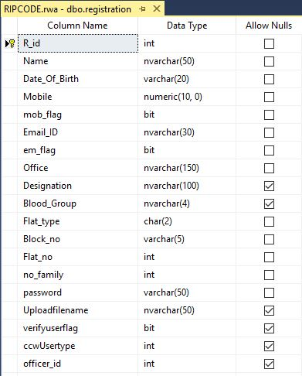

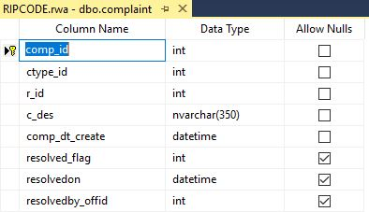

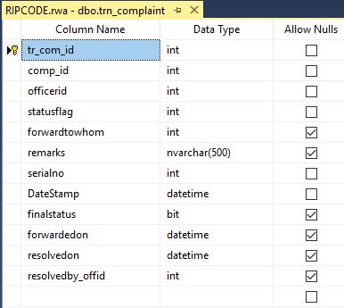

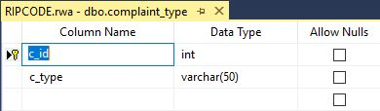

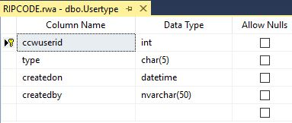

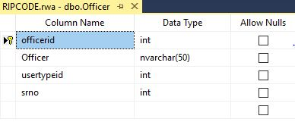

**Chapter 4: RWA COMPLAINT MANAGEMENT SYSTEM ANALYSIS**

**4.1 User Characteristics**

The users of the system are contributors to RWA COMPLAINT MANAGEMENT SYSTEM as well as those who avail from RWA COMPLAINT MANAGEMENT SYSTEM, along with the administrators who maintain the system. The users and the administrators are assumed to have basic knowledge of the computers and Internet browsing. The administrators of the system not only need to have more knowledge of the internals of the system but have to be specialized with regard to working with queries in SQL, understanding typical complexities of a database and the nuances involved in updating, deletion and modification of data that happens in a database. They should also be capable of rectifying small problems that may arise due to disk crashes, power failures and other unwarranted incidents to keep the system up and running.

Apart from this, familiarity with ASP.NET and C# along with HTML are some languages that are prerequisite to fully understanding the code in which RWA COMPLAINT MANAGEMENT SYSTEM was written in. It is the foundational framework that keeps RWA COMPLAINT MANAGEMENT SYSTEM alive and will in the future. RWA COMPLAINT MANAGEMENT SYSTEM is in itself is self-sufficient that is the user does not need to install any software or any special drivers for its functioning. All what is needed is an internet browser with a good uninterrupted internet connection.

**4.2 Constraints**

4.2.1 The information of all the users must be stored in a database that is accessible by RWA COMPLAINT MANAGEMENT SYSTEM and its administrators.

4.2.2 RWA COMPLAINT MANAGEMENT SYSTEM in the future will be on public servers so that public which is connected to the internet can access it 24 hours a day and 7 days a week.

4.2.3 Authentication: The users must have their correct usernames and passwords to enter into RWA COMPLAINT MANAGEMENT SYSTEM. Without entering correct credentials, you will not be able to login to your RWA COMPLAINT MANAGEMENT SYSTEM account and will not be able to participate in contribution or avail tasks from RWA COMPLAINT MANAGEMENT SYSTEM

**4.3 Assumptions and dependencies**

1. The users involved with RWA COMPLAINT MANAGEMENT SYSTEM should have sufficient knowledge of computers.

2. The users must know English language, as the user interface will be provided in English

3. The RWA COMPLAINT MANAGEMENT SYSTEM can access the database that is constantly being updated by the contributors.

4. RWA COMPLAINT MANAGEMENT SYSTEM may undergo maintenance sessions, in which case RWA COMPLAINT MANAGEMENT SYSTEM may not be active i.e the site may not work. We do not take responsibility for any update of an event that may happen in that time.

**4.4 Introduction:**

System analysis is a process of the analyst understands of the application domain. The analysis interacts with the stakeholders in the system to discover their requirements and organizes them into clusters. If there are multiple stakeholders whose requirements conflicts, find and resolve such conflicts. Then prioritize the requirements and family validates them.

**4.5 Data flow diagram:**

Data flow diagram (DFD) is a way of expressing system requirements in a graphical form. A DFD has the purpose of clarifying system requirements and identifying major transformations that will become programs in system design. So it is the starting point of the design phase that functionally decomposes the requirements down to the lowest level of details.

Data flow diagram is a logical model of a system. That model does not depend on the hardware, software data structures or file organization. It only shows the data flow between modules of entire system.

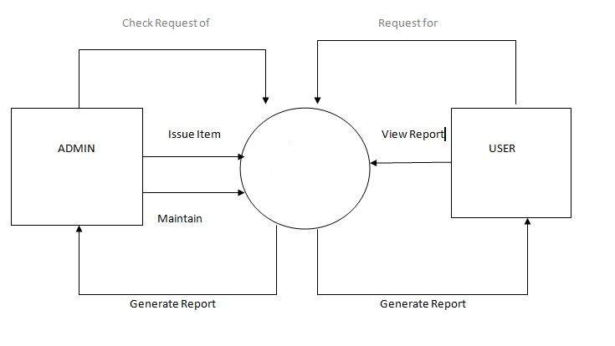

**Entity Relationship Diagrams:**

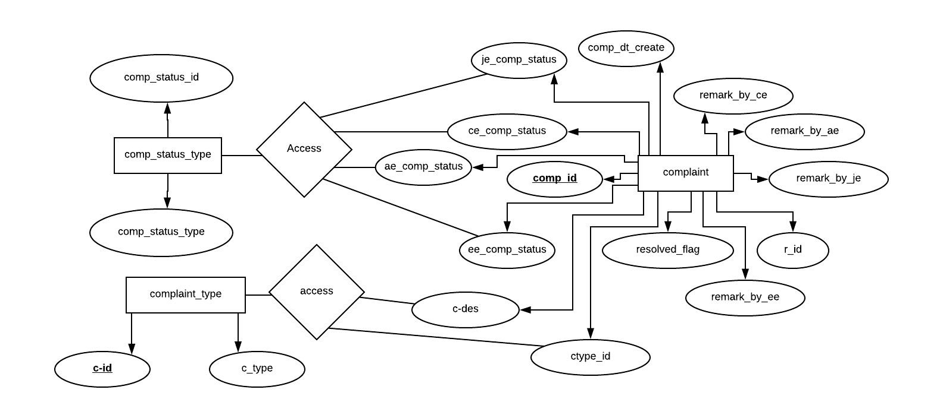

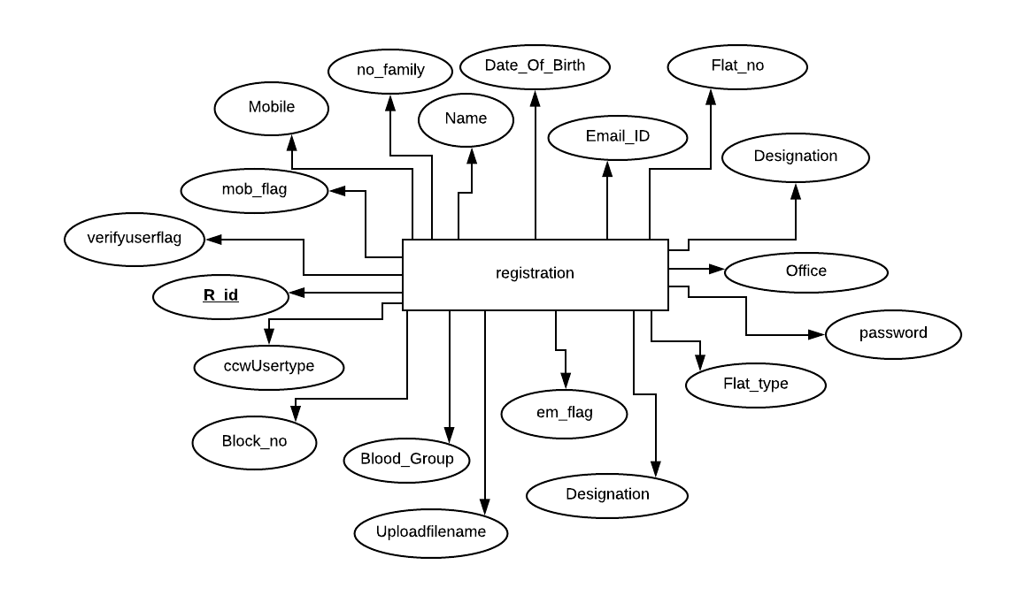

**Chapter 5: Functional Provisions**

This section describes in detail all the functional provisions that RWA COMPLAINT MANAGEMENT SYSTEM intends to provide to the concerned users.

**5.1 Functionality**

**5.1.1 Login Capabilities**

RWA COMPLAINT MANAGEMENT SYSTEM shall provide the users with login capabilities. User must enter his username and password that he made during the registration procedure.

**5.1.2 Complaint page**

The user at any time can change the relevant details he uploaded during registration period for factual accuracy.

**5.1.3 Login Session**

The users can logout after being active on the RWA COMPLAINT MANAGEMENT SYSTEM site for a specific duration of time. This is a security layer that can be helpful in several scenarios.

**5.2 Usability**

RWA COMPLAINT MANAGEMENT SYSTEM shall allow the users to access the system from the Internet using browser. RWA COMPLAINT MANAGEMENT SYSTEM has been created in Microsoft Visual Studio, where most of the code is written in ASP.NET and C#. RWA COMPLAINT MANAGEMENT SYSTEM uses a web browser as an interface. Since all concerned users are familiar with the general usage of browsers, no specific training is required. RWA COMPLAINT MANAGEMENT SYSTEM is user friendly and self-explanatory.

**5.3 Reliability**

RWA COMPLAINT MANAGEMENT SYSTEM intends to be independent and fault-tolerant. When it comes to cyber attacks and unethical hacking, we at RWA COMPLAINT MANAGEMENT SYSTEM aim to provide full proof cryptographic measures to counter such attacks and prevent them from happening in the first place.

Considering the amount of data that is being stored in our databases, keeping RWA COMPLAINT MANAGEMENT SYSTEM away from unauthentic users is our priority. People are also recommended from not making multiple accounts at RWA COMPLAINT MANAGEMENT SYSTEM a single individual must have only one account associated in his name,

**5.3.1 Availability**

RWA COMPLAINT MANAGEMENT SYSTEM is available 100% for the user and can be used 24 hours a day, 365 days a year. RWA COMPLAINT MANAGEMENT SYSTEM shall be operational 24 hours a day and 7 days a week. It will also be accessible from any part of India irrespective of the geographical terrain as long as access to computer and an uninterrupted internet connection is made available.

**5.3.2 Mean Time Between Failures (MTBF)**

The system will be developed in such a way that it may fail once in a year.

**5.3.3 Mean Time to Repair (MTTR)**

Even if the system fails, the system will be recovered back up within an hour or less.

**5.3.4 Accuracy**

The accuracy of the system is limited by the accuracy of the speed at which the employees of the library and users of the library use the system.

**5.3.6 Access Reliability**

The system shall provide 100% access reliability,

**5.4 Performance**

**5.4.1 Response Time**

Most of the WebPages in ASP.NET take an average to longer time to load than websites written in other languages. The response time is something that can however be controlled or reduced.

**5.4.2 Administrator/Librarian Response**

RWA COMPLAINT MANAGEMENT SYSTEM shall take as less time as possible to provide service to the concerned users involved.

**5.4.3 Resource Utilization**

The resources are modified according the user requirements and also according to the users who are contributing to RWA COMPLAINT MANAGEMENT SYSTEM or availing from RWA COMPLAINT MANAGEMENT SYSTEM.

**5.5 Supportability**

RWA COMPLAINT MANAGEMENT SYSTEM designers shall take in to considerations the following supportability and technical limitations.

**5.4.1 Internet Protocols**

The system shall be comply with the TCP/IP protocol standards and shall be designed accordingly.

**5.4.2 Information Security Requirement**

RWA COMPLAINT MANAGEMENT SYSTEM shall support its own protocol for information security requirements and will mention in future any standards of information security that we will comply and cooperate with same.

**5.4.3 Maintenance**

The maintenance of RWA COMPLAINT MANAGEMENT SYSTEM shall be done as per the maintenance contract.

**5.4.4 Standards**

The coding standards and naming conventions will be as per the American standards.

**5.5 Design Constraints**

**5.5.1 Software Language Used**

The languages that have been used for coding the RWA COMPLAINT MANAGEMENT SYSTEM are Active Server Pages (ASP), C#, along with some HTML, JavaScript, and VBScript. All of the work was done in Microsoft Visual Studio 2017. As far as database design is concerned, we used SQL Server 2017 for working on the coding phase of the RWA COMPLAINT MANAGEMENT SYSTEM.

**5.6 Purchased Components**

RWA COMPLAINT MANAGEMENT SYSTEM does not require any user as of now to purchase any thing for registering or accessing the RWA COMPLAINT MANAGEMENT SYSTEM website. Apart from a computer and an uninterrupted internet connection nothing more is required. You need to hire a web server and a sql server because these are now on the local host.

**5.7 Interfaces**

**5.7.1 User Interfaces**

Will make use of the existing Web Browsers such as Microsoft Internet Explorer, Google Chrome or Mozilla Firefox. The user interface of the system shall be designed as shown in the user interface prototypes.

**5.7.2 Hardware Interfaces**

In the near future, existing Local Area Network (LAN) will be used for collecting data from the users and also for updating various information databases relevant to RWA COMPLAINT MANAGEMENT SYSTEM

**5.7.3 Software Interfaces**

A firewall will be used with the server to prevent unauthorized access. In future we intend to have several cryptographic implementations that will also be enabled to provide greater level of security to RWA COMPLAINT MANAGEMENT SYSTEM and user’s information in general.

**5.7.4 Communications Interfaces**

In future, RWA COMPLAINT MANAGEMENT SYSTEM will be connected to the World Wide Web and made accessible to people in all international countries.

**Chapter 6: Future Scope**

**6.1 Language interfaces**

Currently as of now RWA COMPLAINT MANAGEMENT SYSTEM is in English. We intend to make RWA COMPLAINT MANAGEMENT SYSTEM available in other regional languages of India so that people in rural areas and far flung areas can understand and work with it. Reaching people in far flung areas is an area of special interest that RWA COMPLAINT MANAGEMENT SYSTEM is personally concerned about.

**6.1.1 Cryptographic measures**

Increasing internet connectivity brings pros and cons. It connects more people but also empowers a certain group of people to bring harm for their own agendas. At RWA COMPLAINT MANAGEMENT SYSTEM we have sensitive data relevant to Users as well as information related to variety of medicines which must be kept confidential To increase security, we intend to implement a variety of cryptographic implementations/cryptosystems.

Reasons we intend to do this is to provide a full proof mechanism to prevent unauthorized access into a given users account, to prevent SQL injection attacks and any other cyber threat that could possibly be encountered on the World Wide Web.

Some of the cryptosystems in future we would like include or work with would be RSA (cryptosystem), PGP (Pretty Good Privacy), IP Security (IPSec) Protocol. Apart from these we also have various algorithms that can also be included as security measures to prevent various unwarranted/unprecedented cyber attacks.

**6.1.2 Forgot Password functionality**

It so happens that users may misplace or forget their passwords, causing them unable to login to their RWA COMPLAINT MANAGEMENT SYSTEM account. This can be very frustrating, along with the creation of a new account to be time consuming. For this reason functionality of forget password would allow the user to have a link sent to the user’s personal email that will allow him to reset his/her password and thus regain control/access to his/her RWA COMPLAINT MANAGEMENT SYSTEM account.

**6.1.3 Text Slider**

There should be a mechanism to keep the user updated on various changes taking place at RWA COMPLAINT MANAGEMENT SYSTEM from time to time or any alerts/messages that keep the user updated on the advancements RWA COMPLAINT MANAGEMENT SYSTEM continues to undertake on its journey to helping people. Text slider would be one of those mechanisms which has text and other information dynamically moving from one place to another informing users of any maintenance issues being resolved. progress thus far made and any positive news we would like our users to know.

**FEASIBILITY STUDY**

A Feasibility Study is conducted to select the best system that meets performance requirements.

**PROJECT TESTING**

**UNIT TESTING:**

The purpose of unit testing phase (sometimes called the implementation phase) of software development is to translate the software design into source code. To enable the Engineers to write good quality programs, every software development organizations normally its own coding standard that suits itself.

**MODULE TESTING:**

Each module is unit tested to determine the correct working of all the individual modules. It involves testing of each module in isolation as this the most efficient way to debug the errors. Testing a module in isolation is that the other module, with which this module has to be unit interfaced, may not be ready.

**SYSTEM TESTING:**

When all the modules have been successfully integrated and tested system testing is carried out. The goal of system testing is to ensure that the develop system confirm to its requirement aid out in SRS document system testing is normally carried out in a planned manner according to system planned document.

**CONCLUSION**

RWA COMPLAINT MANAGEMENT SYSTEM (Resident welfare association) is the project for the residents of the Society, which employs the best features of ASP.NET. Main purpose of this project is to enhance connectivity among the residents of the society. Be it any Event, party, any function or festivals, you will be in touch with RWA COMPLAINT MANAGEMENT SYSTEM. RWAs are typically registered through co-operative societies acts, which require groups to have minimum of fifteen members from a given area. These acts also set the rules for the establishment of RWA COMPLAINT MANAGEMENT SYSTEM’s by-laws, which include such things as membership criteria, voting rights, and the conditions under which RWA’s officers can initiate legal proceeding on behalf of the registered society.

RWA COMPLAINT MANAGEMENT SYSTEM project uses all the features of ASP NET. SQL Server and C# is used for managing databases. Understanding the subtle dynamics of user interface along with working with databases and coding required precision, and deep understanding of concepts. This project has been made interactive with JavaScript and CSS. RWA COMPLAINT MANAGEMENT SYSTEM events updating has been made very easy and can be handled without any prior knowledge to programming.

**REFERENCES**

1. Bhasin, Hersh. ASP.NET Professional Projects. United States: Premier Press, 2002.
2. Doug Lowe. Jeff Cogswell. Ken Cox - Microsoft MVP. ASP.NET 2.0 All-in-one Desk Reference for Dummies (ASP.NET 2.0 for Dummies). Wiley, 2006.
3. Lowe, Doug. ASP.NET 2.0 Everyday Apps for Dummies. Hoboken, NJ: Wiley, 2006.
4. "MasterPage Using Masterpages, and Inheritance." Asp.net. Accessed June 24, 2016.

http://stackoverflow.com/questions/942036/masterpage-using-masterpages-and-inheritance.

1. Paz, José Rolando Guay. Beginning ASP.NET MVC 4.
2. Perdeck, Matt. ASP.NET Site Performance Secrets: Simple and Proven Techniques to Quickly Speed Up Your ASP.NET Web Site. Packt Publishing, 2010.
3. Siemer, Andrew, and Richard Kimber. ASP.NET MVC 2 Cookbook over 70 Clear and Incredibly Effective Recipes to Get the Most out of the Many Tools and Features of the ASP.NET MVC Framework. Birmingham, U.K.: Packt Pub., 2011.
4. Spaanjaars, Imar, Paul Wilton, and Shawn Livermore. ASP.NET 2.0 Instant Results. Indianapolis, IN: Wrox/Wiley Pub., 2006.
5. Varallo, Vince. ASP.NET 3.5 Enterprise Application Development with Visual Studio 2008: Problem, Design, Solution. Indianapolis, IN: Wiley, 2009.